Planning Advice Note  Pre-Application Enquiry Form  Householder enquiries | 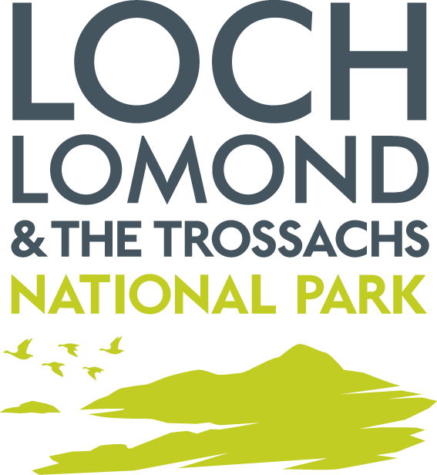

Your Details

1. Your Name

2. Your Address

3. Your Email Address

4. Your Telephone Number(s)
Home:
Mobile:

Basic Details

5. Address of Proposal (if different from above)

6. Type of Property (semi-detached house, flat, terrace house, detached house)

Pick from drop down

7. Description of Proposal

Extensions and Outbuildings

8. Details of any previous extensions, outbuildings (inc. external floorspace in metres square)

9. Description of Extension/Outbuilding

a. Sizes

b. Materials

c. Distance between the proposal and any road

d. Use

e. Parking Provision

10. Is the extension nearer to the road than the original house?
Yes No

Other Alterations or Installations

11. Description of Proposed Alteration, Fence, Gate, Driveway etc.

Other Information Required

- Location Plan or Block Plan
- Sketches of Proposal (only for extensions or outbuildings)
- Photographs of Existing House
- Product Brochures / Detailed Specifications

Please send the completed form and attach to an email and send to: planning@lochlomond-trossachs.org
The subject of the email should be – Pre-Application Enquiry.

Guidance on Completing Form

Type of House
Specify if your property is a flat, terrace, semi-detached, detached.

Previous Extensions/Outbuildings
Please detail any floor area of any previous extensions and outbuildings within 5 metres of your house.

Sketches of Proposal

BLOCK PLAN | DIMENSIONS | ELEVATIONS

