Group Camping Permit Application Form 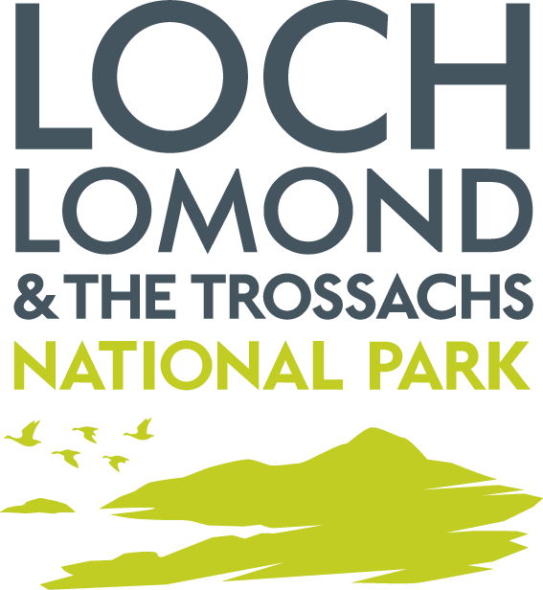

Please provide as much detail as possible and complete all sections of the form.
- Applicant Details  (If an organisation or club please also provide a contact name should we need to speak to you about any information on this form)  The email address provided will be used by us to contact you and notify you of any decisions regarding the application | Name:
 | Club/Group/Organisation:
 | Position/Job title:
 | Address:
 | Post Code:
 | Phone Number:
 | Email address:
- Location(s) applied for | Map Enclosed?  Y/N |  |  |  | Grid references (6 figure standard OS format):
- Location(s) applied for | Description
- Dates Applied for | Start Date |  |  |  |  | End Date
- If required, has the landowner been notified about this application?  Please attach proof of landowner consent. |  |  |  |  |  |  |  |  |  | Y/N
If known, landowner(s)/occupier(s) name and contact details
Name:
Address:
Phone number:
- Are you camping as part of an expedition or longer journey? |  |  |  |  |  |  |  | Y/N
- If yes to Q5 please provide details below of each of the locations within any of the Camping Management Zones you intend to camp at.
Location description | Grid reference |  |  | Start date |  |  | End date |  | Total number of nights
- Please tell us how many people are planning to camp. |  |  | Adults:  Under 16’s:
- Will there be any dogs with the party? |  |  | Y/N  If yes, how many?
- Please give full details of the number and size of any tents, wigwams, bivouacs or shelters that are to be used.
- Will any member of the party be sleeping overnight in a vehicle? |  |  | Y/N
If yes please provide vehicle registration number & number of people sleeping in the vehicle.
- What arrangements are being made for toileting?
- Do you intend to have any fires? |  |  | Y/N
- Do you intend to have any BBQs? |  |  | Y/N
If yes to Q12/13, please provide details of how many and what size and how you will be complying with Byelaw 8.

- What measures are proposed to minimise the environmental impacts of your camping activity?
- Signature of Applicant:
- Date of application:

Please return this form to: Camping Byelaws
Loch Lomond & The Trossachs National Park Authority
Carrochan
Carrochan Rd
Balloch
G83 8EG
campingbyelaws@lochlomond-trossachs.org
01389 722001

For an application to be considered valid you must;
- Complete all relevant sections of this form
- Have the form signed by a person over 18 years of age or the form submitted online and the disclaimer checked by someone over 18
- Provide proof of being a constituted club / group membership or affiliation.
- Provide a minimum of 4 weeks’ notice.

The Park Authority may choose to assign certain conditions to the approval of an application over and above the usual camping permit terms and conditions.

In order to assess your application for exemption from the Byelaw(s), we are requesting some personal information from you, including your name, telephone number and email address. The personal information you provide on this form will only be used for this purpose. Your information will be processed by the Loch Lomond & The Trossachs National Park Authority securely and in accordance with Data Protection legislation.

Loch Lomond and the Trossachs National Park Authority
PRIVACY NOTICE

The information you have provided (“Your Information”) will be processed by Loch Lomond & The Trossachs National Park Authority,Carrochan,Carrochan Road,Balloch,G83 8EG, for group bookings accepted for organised groups that have been authorised to camp in a camping management zone.
You can contact the Park Authority on 01389 722600 or info@lochlomond-trossachs.org
The Park Authority’s Data Protection Officer is our Governance Manager who can be contacted on the below noted details:
Carrochan Road,Balloch,G83 8EG
Email: info@lochlomond-trossachs.org
Tel: 01389 722600

How will your information be used?
Your Information will be used to:
- We will use your email address to email you your booking confirmation and other related information regarding your booking.
- We may use your telephone number, mobile phone number or email address to contact you regarding your booking.
- Our Ranger Service may use the personal data you submit during the booking process to identify you when patrolling in Loch Lomond & The Trossachs National Park.
- We may use your personal data to contact you in the event of a suspected breach of the Loch Lomond & The Trossachs National Park Camping Management Byelaws 2017. Terms and Conditions apply to all bookings made with Loch Lomond & The Trossachs National Park Authority. By making a booking you agree that you have read and agree to these Terms and Conditions.
- We may use your personal data to inform evaluation reports of the Camping Management Byelaws.

What is the legal basis for us to process your data?
The legal basis for processing Your Information is:
Compliance with the Loch Lomond & The Trossachs National Park Camping Management Byelaws 2017.
Do I have to provide my information?
You do not have to provide your information to the National Park Authority
Without the correct information however we may not be able to successfully complete an online booking.
How long will you keep my Information?
We will hold your information from the end of the year it was provided for a period of 3 years. Your information will be retained for the minimum period necessary. Your information will be destroyed under confidential conditions after this period.

Who will you share my information with?

Your information will be accessed by Park Authority staff for the purpose of enforcement of the Loch Lomond & The Trossachs National Park Camping Management Byelaws 2017.

The Park Authority will generally comply with requests for specific information from other regulatory and law enforcement bodies where this is necessary and appropriate.

Will you transfer my data outside the UK?

In general the Park Authority does not transfer personal data outside the UK and on the rare occasions when it does so the Park Authority will inform you.

The Park Authority will only transfer data outside the UK when it is satisfied that the party which will handle the data and the country it is being processed in will provide adequate safeguards for personal privacy.

Your Rights

You have the right to:

- Access Personal data held about you

You have the right to access the personal data the Park Authority holds about you. This right is called a Subject Access Request, often referred to as a SAR.

You can receive a copy of your personal data held by the Park Authority, details on why it is being used, who it has been/will be shared with, how long it will be held for, the source of the information and if the Park Authority uses computer systems profiling to take decisions about you. Details on how to submit a Subject Access Request can be found on our website at:

http://www.lochlomond-trossachs.org/park-authority/freedom-of-information/accessing-personal-information/

- Rectification of Personal Data

You have the right to request that the Park Authority corrects any personal data held about you that is inaccurate.

- Erasure of Personal Data

You have the right to request that the Park Authority deletes personal data about you. This is known as “the right to be forgotten”.

You can request erasure of personal data in certain circumstances , for example:
- The personal data is no longer necessary for the purpose it was collected
- It is being processed unlawfully
- The personal data has to be erased due to a legal obligation the Park Authority is subject to

- Restrict Processing

You have the right to request that the Park Authority restrict processing your personal data if
- You think the personal data is inaccurate
- The processing is unlawful
- The Park Authority no longer needs the personal data but you may need it for legal purposes
- You object to the Park Authority processing for the performance of a public interest task or any official authority vested in the Park Authority.

- To Object

You have the right to object to the Park Authority’s use of your personal data. The Park Authority will have to demonstrate why it is appropriate to continue to use your personal data.

Complaints

If you are unhappy with the way the Park Authority has processed your information you have the right to complain to the Information Commissioner’s Office:

The Information Commissioner's Office - Scotland
45 Melville Street
Edinburgh
EH3 7HL

Telephone: 0303 123 1115
Email: Scotland@ico.org.uk
You should however raise any concerns regarding our handling of your information with the Park Authority in the first instance. Details of our complaints process can be found at:
http://www.lochlomond-trossachs.org/park-authority/how-to-make-a-complaint/
The Park Authority does not use profiling or automated decision making processes.

