Planning Advice Note  Tree Enquiry Form  Is This Tree Protected? | 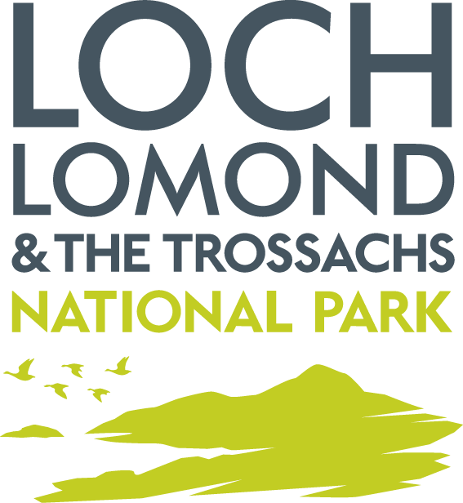

This form should be used by anyone wanting to find out whether a tree is protected or not.

Trees can be protected by: i) a Tree Preservation Order, ii) conditions of a planning permission or iii) being within a conservation area.

Consent is needed for tree works to protected trees. Only use this form if you want to find out whether a tree is protected. If you know a tree is protected then you can proceed to apply online - see information at the end of this note.

On receipt of this completed form we will write back to confirm whether the tree is protected and to advise how to go about applying for consent to carry out works to the tree(s), if needed.

Your Details

1. Your Name

2. Your Address

3. Your Email Address
If you provide an email address then this will be used as the main method to contact you.

4. Your Telephone Number(s)
Home:

Mobile:

Information about the tree(s)

5. Location of Tree(s) – if different to your address

6. Description of Tree(s) – type of tree (if known) and circumference of the trunk (measured 1.5m (5’) above ground level)

Other Information

Photographs of the tree(s) and a map showing the location of the tree on the property may be useful (but are optional).

Please complete this form and attach it to an email marked Tree Enquiry and send to: planning@lochlomond-trossachs.org or post to:
Loch Lomond & the Trossachs National Park Authority
Carrochan
Carrochan Road
Balloch
G83 8EG

Application for Tree Works - if you already know the tree is protected then you do not need to complete this form. You can apply for consent electronically using the ‘Application for Tree Works’ form via https://eplanning.scotland.gov.uk which also has useful guidance notes.

