Planning Advice Note  Pre-Application Enquiry Form  Non-householder enquiries | 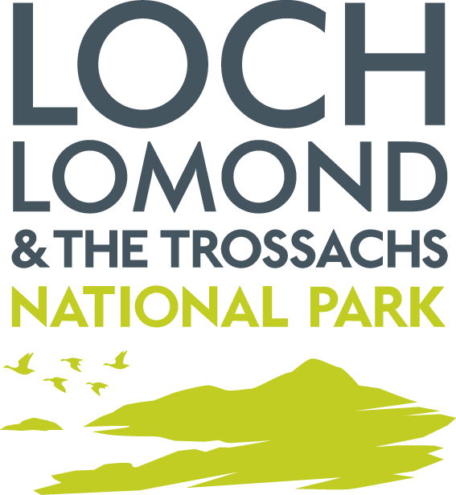

Applicant Details

1. Your Name

2. Your Address

3. Your Email Address

4. Your Telephone Number(s)
Home:

Mobile:

Agent Details (if applicable)

5. Company Name

6. Contact Name

7. Your Address

8. Your Email Address

9. Your Telephone Number(s)
Home:

Mobile:

Details of Proposal

10. Address of Proposal

11. General Description of Proposal
For instance – Erection of 5no. affordable housing units, Erection of 2no holiday letting (short-term) chalets.

12. Description of Proposed Building Works (if applicable)

a. Dimensions (length, width, height in metres)

b. Materials for Walls and Roof

c. Colour of External Walls/Roof

d. Parking Provision – number proposed

e. Access to site (new or existing)

f. Trees affected Yes No
13. Description of Change of Use
(if applicable)

a. Existing Use

b. Proposed Use

c. Parking Provision

Please state the Class use as identified in The Town and Country Planning (Use Classes) (Scotland) Order 1997:
http://www.legislation.gov.uk/uksi/1997/3061/schedule/made

14. Description of Proposed Alteration, Fence, Gate, etc. (if applicable)

15. Description of Proposed Engineering Works (if applicable)

EIA Development

EIA Development is defined by Schedule 1 and Schedule 2 of The Town and Country Planning (Environmental Impact Assessment) (Scotland) Regulations 2017 Details can be found at:
http://www.legislation.gov.uk/ssi/2017/102/contents/made
Further information on the EIA process can be found in Planning Circular 1/2017: Environmental Impact Assessment regulations at:
https://www.gov.scot/publications/planning-circular-1-2017-environmental-impact-assessment-regulations-2017/

16. Is the Proposal an EIA development as defined by Schedule 1 or 2 of the EIA Regulations?

Yes
No
Don’t Know

17. Are you seeking an opinion on whether the proposal is an EIA development?

Yes No

Information to Enclose

Please submit as much of the following as possible:
- Location Plan
- Site/Block Plan
- Sketches of Proposal
- Photographs of Site
- Surveys of the site – topography, flood, tree, protected species etc.
- Product Brochures / Detailed Specifications

Major Development

Major Developments are defined by the Hierarchy of Developments Regulations 2009. Details can be found at:
http://www.legislation.gov.uk/ssi/2009/51/pdfs/ssi_20090051_en.pdf
If the development is Major then a Proposal of Application Notice must be submitted to us prior to submitting an application.

18. Is the proposal a Major development as defined by the Hierarchy of Developments Regulations?

Yes
No
Don’t Know

19. Are you seeking an opinion on whether the proposal is a major development?

Yes No

Please send the completed form and attach to an email and send to: planning@lochlomond-trossachs.org

