Loch Lomond & The Trossachs National Park Authority
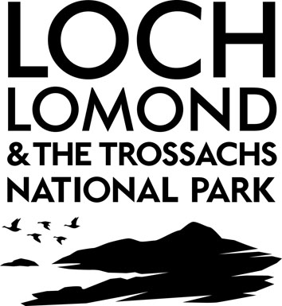
School/ Group Booking Form
Please return the completed form by post or email to:
Education
Loch Lomond & The Trossachs National Park
Carrochan
Carrochan Road
Balloch
G83 8EG
Tel: 01389 722 125
Email: education@lochlomond-trossachs.org

Your Group: Please note we require 4 weeks notice prior to delivery
Name & Address of School/ Group: |  |  | Telephone:
Name & Address of School/ Group: |  |  | Day: | Evening:
Contact Name: |  |  | E-mail:
Group Size: | No. in group: | Group age: | Number of supervising adults:
Please specify any special needs or requirements of the group which may impact on delivery:

If required, please notify us of medical requirements of any participants when confirming the booking.
Photo consents: Do you give National Park permission to take images of your group? Yes / No
Delete as appropriate

Your Session: Your booking request will be determined against other work commitments.
Your session is not booked until you receive confirmation from the National Park.
Date:
Time:  (if visiting the Park, please state time you intend to arrive at NP site and time you need to leave) |  | Starts: | Ends:
Proposed Activity (please tell us in detail what the group learning stage is, topics recently covered and how the Rangers activities will reinforce this)

Proposed location:
Group Leader | Signature: |  |  | Date:
So that we can continually improve our service we would like you to comment on how you thought your visit to the National Park went. We welcome any new ideas and comments. Please complete a short education activities feedback questionnaire by following this link http://www.lochlomond-trossachs.org/park-authority/how-we-can-help/outdoor-learning/contact-outdoor-learning-team/ Thank you.

Personal Information
The personal information you provide on this form will be used for the purpose of managing the education booking.
Your information will be processed by the Park Authority in accordance with data protection legislation. We will retain your personal details for 2 years. If you have any queries about your rights under data protection or about how we are using your personal data please email us at info@lochlomond-trossachs.org .

Important information

Your booking is not complete until you receive a confirmation email from the education service.

Please give a minimum of four weeks’ notice when arranging a school/group visit to the Park.

Please note: Occasionally the National Park Authority may wish to take photographs of your group participating in activities. If this is something you will not provide consent for please advise the National Park Authority at the time of booking and we will ensure your wishes are adhered to.

The National Park Authority will keep the images for no longer than four years and will only use them for promotional purposes.

Health and Safety

Rangers work with a ratio of 1 Ranger to 15 group participants, excluding adult helpers accompanying the group. Rangers are vetted by Disclosure Scotland, they complete Risk Assessments for all activities provided, are qualified First Aiders and always carry first aid kits. A copy of the Risk Assessments can be sent to you if required. For further guidance on health and safety related to outdoor learning please visit Education Scotland’s website, and download the guidance for Off Site Visits.

Cancellation

If you are unable to carry out your visit please let us know as soon as possible so that alternative arrangements can be made.

Group Responsibilities
During your visit the Ranger(s) will be responsible for guiding and leading your group, however it remains the responsibility of the group leader/teacher to oversee the discipline and behaviour of the group/class. Please respect the people living and working in the National Park, follow the Scottish Outdoor Access Code and always dispose of your litter in a responsible manner. The National Park Authority observes the right to stop or cancel activities should the behaviour of the group cause concern.

