PLANNING & ACCESS COMMITTEE

PARTICIPATION FORM

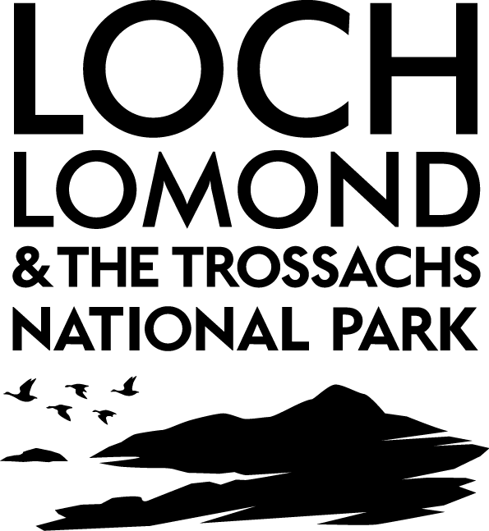
NOTE: All relevant parties who have made a written representation (or any spokesperson representing them) and who wish to make an oral representation to the Committee must submit a public participation form in writing or by electronic mail to the Committee Clerk no later than 12 noon two and a half clear working days prior to the designated Committee meeting. (for example, if the meeting is on a Monday, requests must be received by 12 noon on the previous Wednesday). Any requests received after this deadline will only be considered in exceptional circumstances and at the discretion of the Committee. The Committee Clerk will confirm receipt of all requests.

Please refer to the guidance leaflet prior to completing this form.

APPLICATION DETAILS
Date of meeting:
Planning Application No.

DETAILS OF SPEAKER
Name of speaker:
Address:

Daytime contact number:
e-mail address:
PLEASE TICK THE APPROPRIATE BOX:
1. | I wish to speak: in objection to the proposal  in support of the proposal
2. | At the meeting I wish to represent: myself  Another person / organisation
3. | If representing another person or an organisation, please give details below  ____________________________________________________________  Please tick here to confirm that you have authorisation to represent the above party
PLEASE PROVIDE A SUMMARY OF YOUR REPRESENTATION Note: Only relevant planning matters can be raised - please see overleaf for guidance

Please complete all sections of Page 1 and return this form by email to: committeeclerk@lochlomond-trossachs.org Committee Clerk, Loch Lomond & The Trossachs National Park, Tel: 01389 727750

GUIDANCE ON RELEVANT PLANNING MATTERS
Note: The following examples are given for guidance, however, the lists are not exhaustive
Relevant | Not Relevant
- Structure and Local Plan Policies;  - Government planning guidance;  - Planning law and previous decisions;  - Highway safety and traffic;  - Impact on residential amenity;  - Design appearance and layout;  - Impact on trees, listed buildings, conservation areas and landscape;  - Relationship with existing buildings and uses; or  - Noise, disturbance and smells. | - Boundary or area disputes;  - Suspected future development;  - The applicant’s perceived motives;  - Loss of view; or  - Effect on value of property.

Data Protection Act 2018, Freedom of Information (Scotland) Act 2002 and

Environmental Information (Scotland) Regulations 2004

This Public Participation Form is only for the use of the Park Authority to enable us to schedule a time to allow you to make representations at the designated Planning Committee meeting. A copy of your participation form may be provided to our Planning Committee Members in advance of the designated Planning Committee meeting. Please note that your name will be disclosed at the designated Planning Committee meeting, but your other personal details (address, telephone number and email address) will only be used if the Park Authority need to contact you to discuss your representation or to clarify any information which you have added to the form.

Your information will be processed by the Park Authority securely and in accordance with the Data Protection Act 2018. We will
retain your personal details for four years beginning from the committee meeting date in accordance with the Local Government
(Access to Information) Act 1985, s50D. If you have any queries about your rights under data protection or about how we are using
your personal data please email us at info@lochlomond-trossachs.org.

As the Park Authority is subject to the provisions of the Freedom of Information (Scotland) Act 2002 and the Environmental Information (Scotland) Regulations 2004, your completed Public Participation Form may be the subject, or fall within the scope, of a request made under the aforementioned legislation.

Please tick this box if you do not wish your personal details to be disclosed to other speakers who are speaking in objection/in support (delete as applicable). Your personal details will only be provided to assist with coordination should there be several people wishing to speak.

For completion by Park Authority

Form received:
Date confirmed:
Confirmed by:

