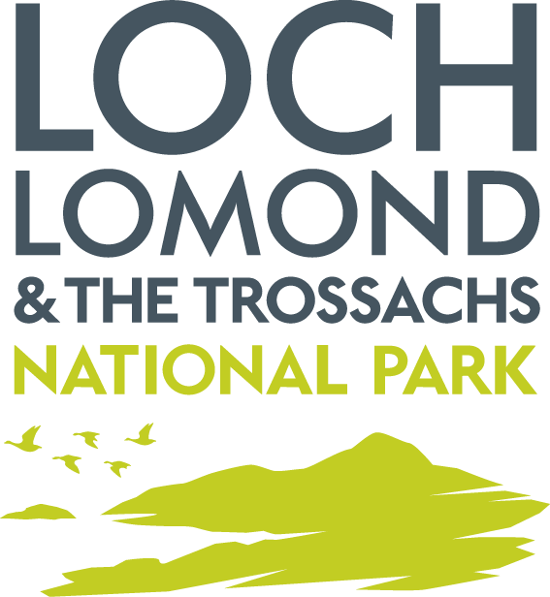

Updated Callander South Masterplan Framework (Planning Guidance)

Habitats Regulations Appraisal

January 2023

Section 1 - Introduction

This document represents the Habitats Regulations Appraisal (HRA) of the updated Callander South Masterplan Framework. The Framework will become planning guidance providing additional guidance to what is already contained in the Local Development Plan and other related planning guidance. These plans set the statutory policy context for determining applications in this area. These ‘parent’ plan policies have been subject to SEA and HRA as part of their preparation.

The Conservation (Natural Habitats, & c.) Regulations 1994 require that certain plans which are likely to have a significant effect on a European site must be subject to an ‘Appropriate Assessment’ by the plan-making authority. The process for determining whether an appropriate assessment is required, together with the appropriate assessment itself – is known as the Habitats Regulations Appraisal.

European sites are Special Protection Areas (SPAs) designated under the EC Birds Directive to protect wild birds and Special Areas of Conservation (SACs) designated under the EC Habitats Directive to protect particular habitats and non-bird species.

Article 6(3) of the EC Habitats Directive requires that any plan (or project) which is not directly connected with or necessary to the management of a European Site, but would be likely to have a significant effect on such a site, either individually or in combination with other plans or projects, shall be subject to an “Appropriate Assessment” of its implications for the European Site in view of the site’s conservation objectives. This procedure is applied in Scotland through The Conservation (Natural Habitats, &c.) Regulations 1994 (as amended), and is known as the “Habitats Regulations Appraisal” of plans. A recent judgement in the EU Court of Justice (C-323/17) has ruled that it is not appropriate, at the screening stage, to take account of measures intended to avoid or reduce the harmful effects of a plan or project on a European Site. As a consequence, mitigation measures have not been taken into account at the screening stage in this HRA.

HRA is mandatory and where an Appropriate Assessment is required, plan-making bodies may not usually adopt the plan, unless the assessment concludes that the plan would not adversely affect the integrity of the site. NatureScot must be consulted as part of any appropriate assessment.

NatureScot guidance ‘Habitats Regulations Appraisal of Plans, Guidance for Plan-making Bodies in Scotland’ (Version 3, January 2015), provides detailed guidance on the separate stages of carrying out an appraisal, and the considerations that need to be taken into account.

Section 2 – Updated Callander South Masterplan Framework - Context

Details of the updated Callander South Masterplan Framework

Name of Responsible Authority: | Loch Lomond and The Trossachs National Park Authority
Title of Plan: | Loch Lomond & The Trossachs National Park Updated Callander South Masterplan Framework – Planning Guidance
Requirement for the Plan:
Subject of the Plan: | Land use and rural development
Period covered by the Plan: | 20 years
Frequency of Updates: | Review every ten years.
Geographic Area covered by the Plan: | Callander South as allocated in the Local Development Plan
Purpose and/or objectives of the Plan: | The Framework seeks to coordinate development and associated infrastructure across the allocated land building on the existing masterplan framework with further information on developer requirements and phasing The Framework will become planning guidance providing additional guidance to what is already contained in the Local Development Plan and other plans and strategies. These plans set the statutory policy context for determining applications in this area. These ‘parent’ plan policies have been subject to SEA and HRA as part of their preparation.
Contact: | Derek Manson  Planning Officer  Loch Lomond & The Trossachs National Park Authority  National Park Headquarters  Carrochan Road  Balloch  G83 8EG  derek.manson@lochlomond-trossachs.org

Map 1 Area of land covered by masterplan framework
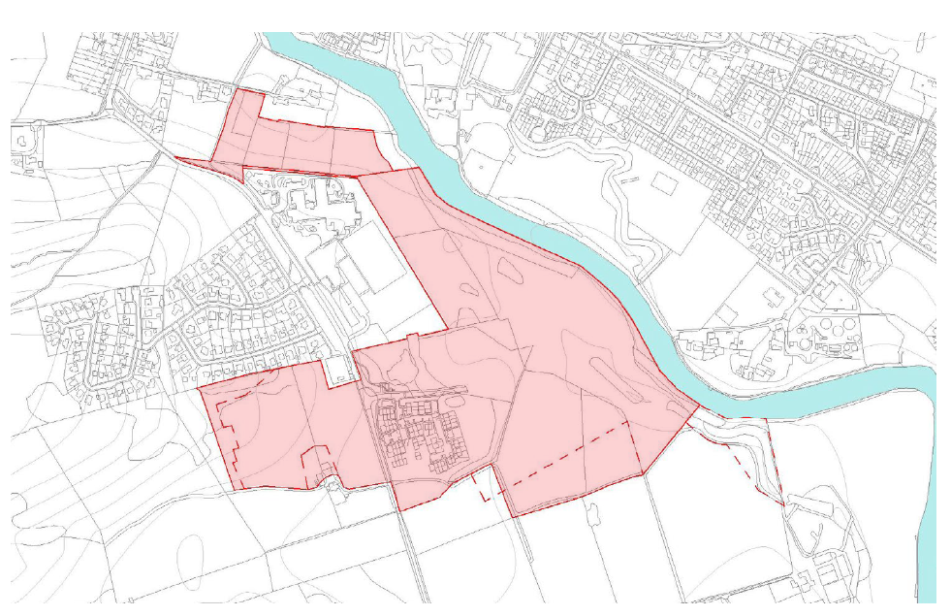

Section 3 - Habitats Regulations Appraisal Methodology

European Sites considered

The Framework covers the area of land in Callander shown above in Map 1. A list of the European sites that should be considered in the appraisal was identified (Table 1 and Table 2).

These sites are based on the most up to date designations as of December 2022. GIS maps were used to determine the location of sites and their potential to be affected by the Framework. Relevant factors were considered such as; the type and scale of actions promoted in the Framework, the qualifying interests of the European sites and their proximity to the framework boundary.

Table 1: European Sites selected as being potentially affected and reasons for their selection

River Teith SAC

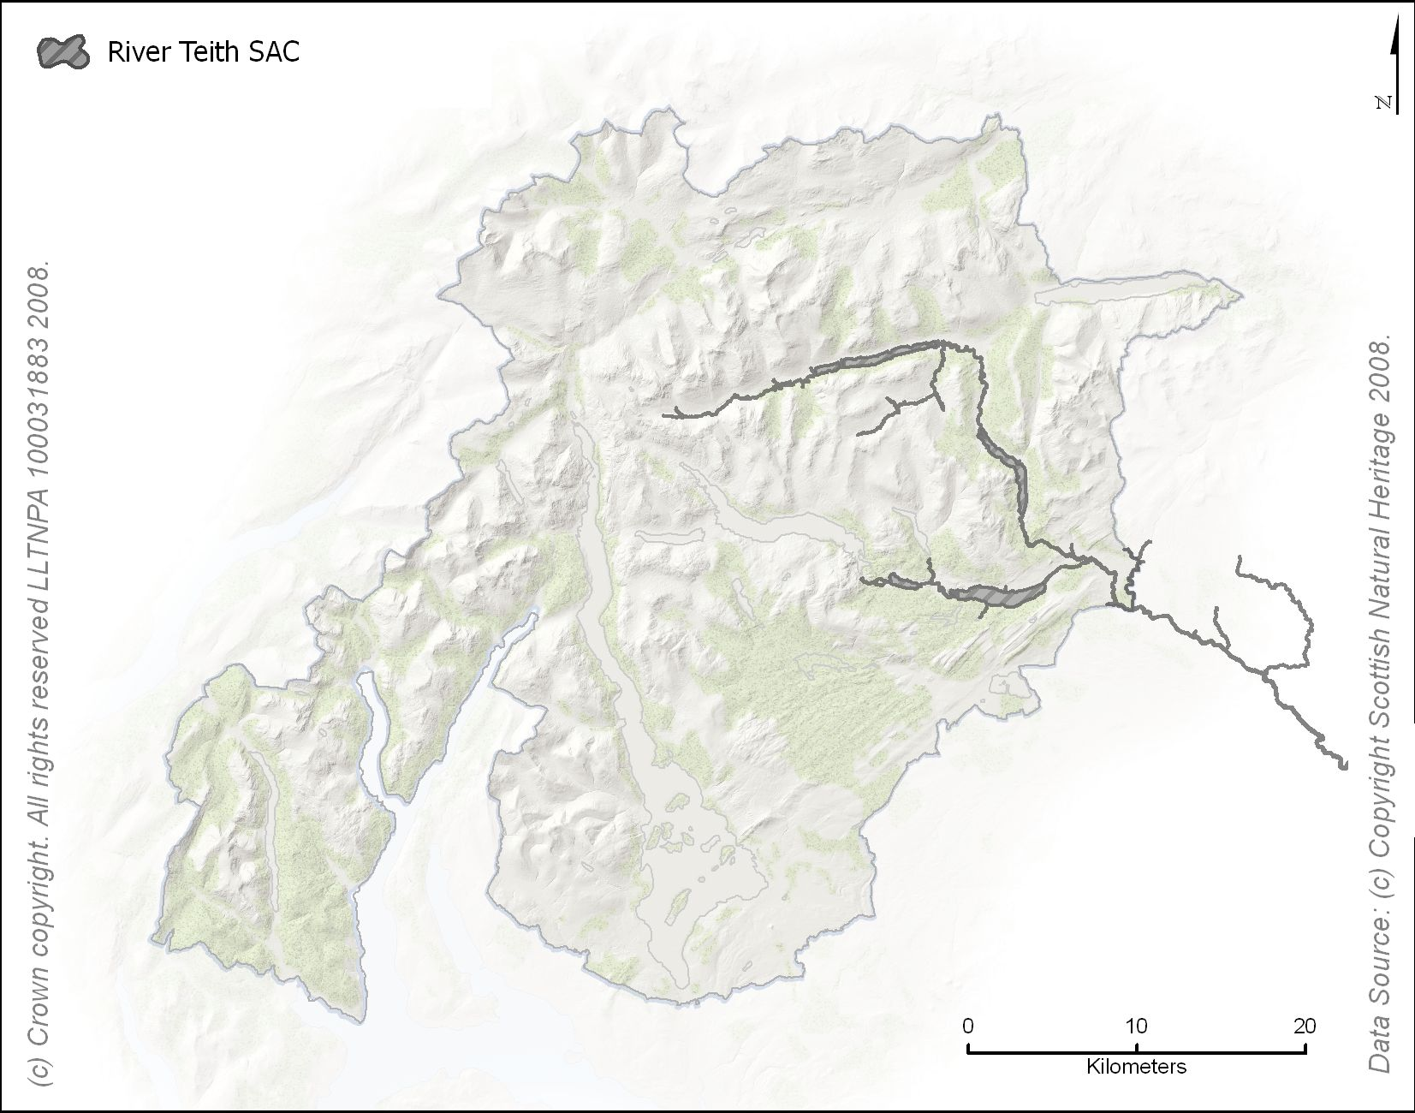

Name of European Site: River Teith
Site Type: Special Area of Conservation
Qualifying Interest(s):
- River lamprey (Lampetra fluviatilis)
- Brook lamprey (Lampetra planeri)
- Sea lamprey (Petromyzon marinus)
- Atlantic salmon (Salmo salar)
Conservation Objectives:
To avoid deterioration of the habitats of the qualifying species (listed above) or significant disturbance to the qualifying species, thus ensuring that the integrity of the site is maintained and the site makes an appropriate contribution to achieving favourable conservation status for each of the qualifying features; and

To ensure for the qualifying species that the following are maintained in the long term:
- Population of the species, including range of genetic types for salmon, as a viable component of the site
- Distribution of the species within site
- Distribution and extent of habitats supporting the species
- Structure, function and supporting processes of habitats supporting the species
- No significant disturbance of the species

Potential for impacts due to the location of the land adjacent to the River Teith. Potential for to impact on the water quality. Need for Appropriate Assessment to further assess impacts

European sites scoped out

European sites outside the red line boundary area were scoped out of the HRA as there will be “No Likely Significant Effect” on these sites as a consequence of the Framework. This conclusion included consideration of the qualifying interests and the distance from the boundary of the site covered by the framework. Further details of the sites and the reasons they have been scoped out of the assessment can be found in Table 2 below.

Table 2: European Sites Scoped Out of the Appraisal

Flanders Moss Special Area of Conversation | Qualifying interests include active and degraded raised bog.There would be no likely significant effect on the extent, distribution, structure and function of the habitat and the processes supporting it given the distance from the site boundary.
Endrick Water Special Area of Conservation | Qualifying interests include lamprey and salmon. As a result of this separation distance, there will be no impacts on the qualifying interests of the SAC as a consequence of any changes in water quality as a result of actions promoted by the framework.
Loch Lomond Special Protection Area | Qualifying interests include overwintering white fronted Greenland geese. The estuary is too far downstream of the boundary area to be affected by any changes in water quality as a result of actions promoted by the framework. In addition, the River Teith SAC lies upstream of this site and any potential impacts on water quality are assessed through consideration of the River Teith SAC in this HRA.
Inner Clyde Special Protection Area | Qualifying interests include overwintering waders such as Redshank. The estuary is too far downstream of the boundary area of the framework to be affected by any changes in water quality as a result of actions promoted by the framework.
Glen Etivie and Glen Fyne Special Protection Area | Qualifying interests include Golden Eagle. The site is sufficiently far enough away from the framework boundary area to ensure that any actions promoted by the framework will not impact on the breeding golden eagle qualifying interest through disturbance or loss/deterioration of supporting habitat. As a result, the Glen Etive and Glen Fyne SPA can be scoped out of the appraisal.
Trossachs Woods SAC | Qualifying Interest include Western acidic oak woodland (Old sessile oak woods with Ilex and Blechnum in the British Isles). As a result of this separation distance, there will be no impacts on the qualifying interests of the SAC as a consequence of any changes in water quality as a result of actions promoted by the framework.
Loch Lomond Woods SAC | As a result of this separation distance, there will be no impacts on the qualifying interests of the SAC

Section 4 - Screening the Updated Callander South Masterplan Development Framework

Having gathered information on the European sites potentially affected by the Updated Masterplan Framework as set out in Table 1, the screening process, as set out in the NatureScot guidance, has been followed:

Table 3: Screening Steps
Step 1 | Screening out general policy statements
Step 2 | Screening out projects referred to in, but not proposed by the Plan  - These could be projects that are to be delivered as part of national infrastructure and promoted by national government and where the plan will play no part in its delivery or are subject to consent directly from Scottish Ministers.
Step 3 | Screening out aspects of the Plan that could have no likely significant effect on a site alone  - Because they are intended to protect the natural environment  - This will not themselves lead to development or other change because they relate to design or other qualitative criteria  - Which make provision for change but could have no conceivable effect on a European site, e.g. because there is no link or path way or any effects would be positive or would not otherwise undermine the conservation objectives of the site;  - Which make a provision for change but which could have no significant effect (and hence a minor residual effect) on a European site because any potential effects would be insignificant, being so restricted or remote from the site that they would not undermine the conservation objectives for the site.  - For which the effects on any particular European Site cannot be identified because the proposal is too general, for example, it is not known where or when or how the proposal will be implemented or where effects may occur or where sites if any may be effected.

As identified in Table 1 it was considered that the only European site where there could be potential for significant effects is the River Teith SAC. This has been taken forward to appropriate assessment shown in Table 4.

Table 4 Appropriate Assessment of Policies and Proposal on the River Teith SAC (alone and in-combination)
Policies and Proposals that may have an effect on the River Teith SAC (alone or in-combination) | Land allocated in Local Development Plan as part of allocation Callander MU2– Claish Farm, Callander (Mixed use visitor experience, economic development, housing and playing field and long-term housing and visitor experience)
Summary of the likely significant effect(s) alone and in-combination (in relation to qualifying interests | Construction and use of new housing, businesses, waste facilities or tourism development and associated infrastructure and additional people living in areas such as Callander, could:  - Affect water quality through mechanisms such as sedimentation or diffuse pollution from runoff from roads and parking areas, increase in runoff rates/patterns and pressure from managing additional foul flow requirements, with scope to harm spawning grounds or altering availability of food or habitats.  - Increase invasive riparian plant species, e.g. from garden escapes or poor landscape planting. These have the potential to alter bank stability and invertebrate composition, altering sediment regime, bank morphology and food availability.  - Have direct physical impacts on riparian habitat. It is important to retain a mix of open and wooded bank side vegetation types as a key habitat influencing stream morphology and contributing nutrient inputs that provide food for these species.  - Water quality could also be affected by air emissions generated from the industrial sites.
Implications for each qualifying interest in the light of its conservation objectives | The River Teith SAC are designated for salmon and three species of lamprey. These species are vulnerable to sedimentation and reductions in water quality, and are dependent on a range of in-stream habitat features for varying stages of their life cycles. Salmon also depend on riparian plants for shade and invertebrates as food. Leaf litter is an important nutrient supply for in-stream invertebrates that are eaten in turn by juvenile salmon.
Mitigation Measures applied or to be taken into account | Proposals within this land allocation will need to comply with natural environment policy NE2, which protects European sites. Additionally, natural environment policies; Protecting the Water Environment (NE10) and Surface Water and Waste Water Management (NE11) policies require developments to have no adverse impact on the water environment, particularly in relation to drainage, sewerage and impacts on the water and riparian environments. Compliance with policies: Enhancing Biodiversity (NE6), Species and Habitats (NE5), Strategic Principles (OP1), Development Requirements (OP2) and conditions on planning permissions will ensure that all initial site landscaping enhances biodiversity, protects species and avoids invasive species. Section 14 of the Wildlife and Countryside Act (1981) will prevent the planting and cultivating of invasive plant species, but does not include a number of species of concern that currently grow in the National Park. SEPA and local authority licensing and permitting regimes (under the relevant legislation) will help mitigate and manage the risk to the water environment and relevant pollution prevention guidance documents. Permits issued by SEPA are subject to HRAs. The Design and Placemaking supplementary guidance provides further guidance on how the policies would be applied in terms of protecting the water environment, undertaking species surveys and designing the proposal using an ecosystem service approach.  In relation to the proposals that may affect the River Teith SAC alone this allocation within the Proposed Plan has an icon in the Local Development Plan that indicates that a European site designation may be affected and indicating that proposals must not have adverse effect on the qualifying interests of the River Teith SAC. In addition, the icon states that an expert appraisal of the potential impacts on the qualifying interest will be required to inform a project-level Habitats Regulations Appraisal. It also highlights that a pre-application enquiry would be recommended to help assist in the scope of the information to be submitted with the application. Compliance with the above policies will ensure that conditions on planning permissions can be used to ensure that Construction Method Statements, and drainage details are submitted, agreed to, and complied with to ensure there is no effect on water quality. The planning guidance provides more details to coordinate development across the site and seeks to guide development away from the river it also includes specific wording around the SAC and SSSI saying “careful consideration will be required  to ensure there are no adverse impacts on the  features of the relevant designations.” .
Conclusion | There will be no adverse effect on the integrity of the European site.

Consideration of likely significant effects in combination
In-combination with other relevant Plans or Projects

The ‘in combination effects’ of the Framework with other plans and projects has also been assessed. In line with NatureScot guidance, elements of the Framework that have individually been screened out because they will have no effect on a European site or because that element is too general in nature, do not require an in-combination assessment. As a consequence, those elements of the Strategy screened out in Table 2 did require an in-combination assessment.

