**Youth Committee handbook contents page**

1. Welcome 2

2. The National Park’s Youth Committee 2

a. Background to the Youth Committee 2

b. What is the role of the Youth Committee? 3

c. What has the Youth Committee achieved so far? 3

d. How the Youth Committee works 3

e. What to expect 4

3. Background: Loch Lomond & The Trossachs National Park Authority 5

a. The National Park 5

b. National Park Aims 6

c. The Structure of the Park Authority and Board 6

d. National Park Partnership Plan 7

Appendix 1 – Youth Committee terms of reference 8

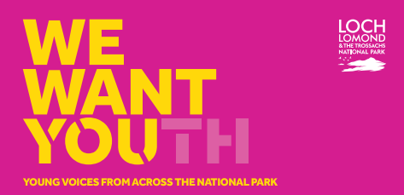

# Welcome

Welcome to the Loch Lomond & The Trossachs National Park Youth Committee. This handbook provides some background to the role of the Youth Committee, how it’s run and what activities you will get involved in. It also gives an overview of the role of the National Park Authority, how we were established, our aims and organisational structure.

# The National Park’s Youth Committee

## Background to the Youth Committee

The National Park Youth Committee is a group of dedicated young people aged between 14-26 years old who are passionate about the National Park and making a difference.

The Committee was formed during the Year of Young People in 2018 to ensure that young people have a voice in the decision making of the National Park Authority, now and for the future.

The Committee gives an opportunity for young people to co-design projects, develop useful life and employment skills, and get to know other young people with similar interests.

**Photo of a Youth Committee meeting**

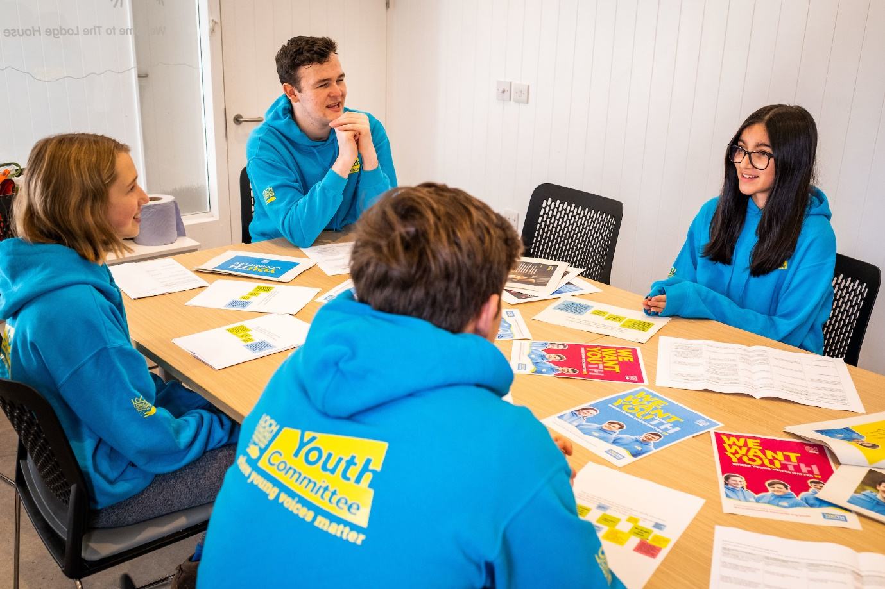

## What is the role of the Youth Committee?

To advocate the views of young people in and around the National Park by:

* Taking part in meaningful consultations and discussions with National Park staff and Board members on issues important to young people.
* Where relevant, co-designing actions to find solutions to issues faced by young people in the National Park.
* Being young ambassadors for the National Park and advocating for it, considering the global climate and nature crises.

## What has the Youth Committee achieved so far?

The Youth Committee has a track record of success with notable achievements to its name including –

* Presenting a paper to the National Park Board for #IWill
* Winning best Youth Engagement category National Parks UK 2019
* Delivering a COP26 speech and wider COP26 engagement including meeting delegates from other international protected landscapes;
* Being recognised as finalists for the Young Scot Awards in 2022;
* Attending the National Parks UK Youth Voice residential;
* Delivering a letter to the CEO of the Park Authority on the climate emergency;
* Interviewing Lorna Slater MSP on green skills;
* One member completed a 9-month placement with us, attending Board meetings and contributing to the evidence base required for the NPPP drafting process.

## How the Youth Committee works

The Youth Committee are active in a number of ways:

**Regular meetings**

* 4 online meetings using Teams, quarterly, the week prior to the National Park Board meetings to allow for strategic discussion. 5pm start, last for around 1 ½ hours.
* 2 in-person meetings, at start and mid-point of year, to allow for Youth Committee developmental activities. Where possible we aim to have one of these in-person meetings as an overnight residential.

Youth Committee members are always welcome to attend the National Park Board meetings, and on occasion will be asked to join a Futures Group’ meeting too.

**Other opportunities to work with the National Park Authority**

Outside of the regular meetings, there will be ad-hoc but frequent opportunities to work more with the National Park Authority. For example:

* Requests to get involved with campaigns and communications opportunities, such as developing content for our social media and website.
* Opportunities to represent the National Park at external events, such as at COP26 or National Park UK youth gatherings.
* Getting involved in specific projects from other teams, such as feeding into sustainable transport project work.
* Undertake placements or work experience at the Park Authority.

We always provide as much notice as possible for these opportunities when they arise. There may be other things that you have in mind that you’d like to do as part of the Committee – feel free to suggest them to us and we will see what we can do!

**Communication**

Main communication is via email from one of the main Youth Committee liaison officers including:

Nik Turner – Education, Inclusion & Volunteer team manager

Ali Cush – Education & Inclusion Adviser

Cathy Owen – Creative Content Coordinator

We also use Basecamp as the current platform to host Youth Committee reports and documents and to allow for member discussions in between meetings.

## What to expect

**From us**

We make a commitment to make your opinions count, ensuring your comments and feedback are incorporated and heard at the highest level of the organisation. We will value your input and use our platforms to amplify your voice. We will provide support to help you as a member of the committee and will help with travel to meetings and cover your travel expenses. We can also help arrange further opportunities such as placements or volunteering. Finally, we will celebrate your work and ensure that your contribution is recognised.

**What you’ll get from being a member**

There are a number of benefits from being a member of the National Park Youth Committee which include –

* Get involved in decision making for the National Park, including attending National Park Board meetings.
* Develop and learn new skills, including project management.
* Build your confidence in working with others, attending meetings and taking on roles such as Chair or Board representative.
* Learn more about Loch Lomond and The Trossachs National Park’s role in addressing the Climate and Nature Crises.
* Co-design opportunities with young people for young people in the National Park
* Gain work experience or placements, have your Volunteering hours accredited.

**What your responsibilities are**

Youth Committee members are expected to:

* Attend a minimum of four meetings per year.
* Actively join in meeting discussions and workshop activities to voice your thoughts and opinions.
* Be ambassadors for the Park in your local community and networks (such as local places, school/ college/ university and other social / youth groups).
* Take on actions within and between meetings to lead the work of the committee and to develop your skills.

# Background: Loch Lomond & The Trossachs National Park Authority

## The National Park

The National Park covers an area of 720 square miles and it’s our job to protect it. This involves addressing the twin crises of the climate emergency and nature loss, welcoming responsible visitors and reducing the impact of recreational pressures and supporting sustainable development within the National Park.

**Map of Loch Lomond & The Trossachs National Park Boundary**

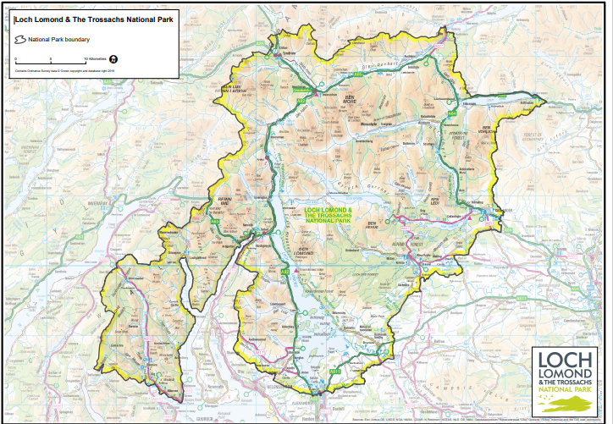

[The National Park (Scotland) Act 2000](https://www.legislation.gov.uk/asp/2000/10/contents) provides the legal framework for the creation of National Parks in Scotland. Loch Lomond and The Trossachs National Park Authority was set up by the [Loch Lomond and The Trossachs National Park Designation, Transitional and Consequential Provisions (Scotland) Order 2002](https://www.legislation.gov.uk/ssi/2002/201/contents/made). The Park was formally established on 8th July 2002 and became operational on 19th July 2002.

## National Park Aims

[The National Park (Scotland) Act 2000](https://www.legislation.gov.uk/asp/2000/10/contents) sets out four aims for Scotland’s National Parks, each one designed to safeguard a sustainable future:

* **Conserve and enhance** – we conserve and enhance the natural and cultural heritage of the area.
* **Sustainability** – we promote the sustainable use of the natural resources of the area.
* **Understanding and enjoyment** – we encourage people to enjoy the special qualities of the area.
* **Social and economic development** – we promote sustainable development of the communities in the area.

Loch Lomond and The Trossachs National Park Authority is an executive [non-departmental public body](https://www.gov.scot/publications/public-bodies-in-scotland-guide/) (also known as an NDPB) of the Scottish Government. Amongst other things, this means our main funding is through a grant from the Scottish Government and are governed by a Board.

## The Structure of the Park Authority and Board

**Structure of the National Park Authority**

Our **Chief Executive** is Gordon Watson, and he leads our **Executive team** which consists of 3 Directors and 3 Heads of Service.

We have 3 main Directorates, overseeing the work for **Environment & Visitor Operations**, **Engagement & Innovation** and **Place** (includes our Planning functions as well as our work with local Communities).

There are around 160 people working for the National Park Authority, in a range of jobs. We also employ many seasonal staff between March and October each year.

**National Park Authority Board**

The [National Park Authority Board](https://www.lochlomond-trossachs.org/park-authority/our-board-committees/national-park-board/) is made up of **seventeen Board Members**. Five members are elected by the community and twelve are appointed by Scottish Ministers, six of these following nomination by the Local Authorities.

Our Members are led by the [Convener,](https://www.lochlomond-trossachs.org/park-authority/our-board-committees/national-park-board/dr-heather-reid/) **Heather Reid** and [Depute Convener,](https://www.lochlomond-trossachs.org/martin-earl/) Martin Earl.

Our Board agree the overall direction of the Park Authority. They also oversee the work of the Chief Executive and National Park staff. Our Board meets in public at least three times a year and [agendas and papers for these meetings](https://www.lochlomond-trossachs.org/park-authority/our-board-committees/meetings/) are posted online before each meeting.

The Youth Committee meet ahead of these Board meetings to discuss and review the papers being presented to provide a young person’s perspective on the topics. A Youth Committee representative is invited to attend the Board meetings in person.

**Infographic of the structure of the National Park Board**

## National Park Partnership Plan

The [**National Park Partnership Plan**](https://www.lochlomond-trossachs.org/wp-content/uploads/2018/02/NPPP2018-23-web.pdf) is the overarching vision to guide how all those with a role in looking after the National Park will work together over the course of five years to ensure a successful, sustainable future for this iconic place.

The Plan guides the work of not just the National Park Authority but of all the organisations and other partners involved in managing the area and making the overarching vision a reality.

Our current [National Park Partnership Plan](https://www.lochlomond-trossachs.org/national-park-plan/) is for the period **2024-2029**. This Plan has been drafted based on an aspiration for more ambitious outcomes for nature and climate by 2040.

The Youth Committee are referenced in this Plan, in the objective to inspire action for climate and nature:

‘Ensuring young people have platforms to advocate and act, embedding their voice in policy and practice by growing membership, and skills of the Youth Committee and Junior Rangers.’

# Appendix 1 – Youth Committee terms of reference

**Terms of Reference**

**Introduction**

The National Park Youth Committee is a group of dedicated young people aged between 14-26 years old who are passionate about the National Park and making a difference.

The Committee was formed during the Year of Young People in 2018 to ensure that young people have a voice in the decision making of the National Park Authority, now and for the future.

The Committee gives an opportunity for young people to get involved with decision making in the National Park, co-design projects, develop useful life and employment skills, and get to know other young people with similar interests.

**Purpose**

To advocate the views of young people in and around the National Park by:

* Taking part in meaningful consultations and discussions with National Park staff and Board members on issues important to young people.
* Where relevant, co-designing actions to find solutions to issues faced by young people in the National Park.
* Being young ambassadors for the National Park and advocating for it, considering the global climate and nature crises.

**Membership**

* Age range: 14–26-year old.
* Members should represent the views of young people both living in the National Park and nearby.
* Members should be from a range of backgrounds to represent diverse views.

**Members Responsibilities**

* Attend a minimum of four meetings per year.
* Actively join in meeting discussions and workshop activities to voice your thoughts and opinions.
* Be ambassadors for the Park in your local community and networks (such as local places, school and other social / youth groups).
* Take on actions within and between meetings to lead the work of the committee and to develop your skills.

**Activities**

* 4 online meetings, quarterly, the week prior to the National Park Board meetings to allow for strategic discussion.
* 2 in-person meetings, at start and mid-point of year, to allow for Youth Committee developmental activities. Where possible, one of these in-person meetings is an overnight residential.
* Creation of an annual plan for the priorities for the Youth Committee; aligned to the National Park Partnership Plan.
* Reviewing and giving input on key pieces of National Park work and Board papers that have relevance to young people, including;
  + Actively joining in discussions and workshops with National Park staff.
  + Providing feedback on Board papers, either in meetings or by summary to the Board youth champion, or by having representation at Board meetings.
* Leading on actions related to or outlined within our annual plan.
* Supporting the recruitment and induction of new members when relevant.