Loch Lomond Islands
Deer Management Group
2024 – 2029
Prepared by Kevin McCulloch, NatureScot

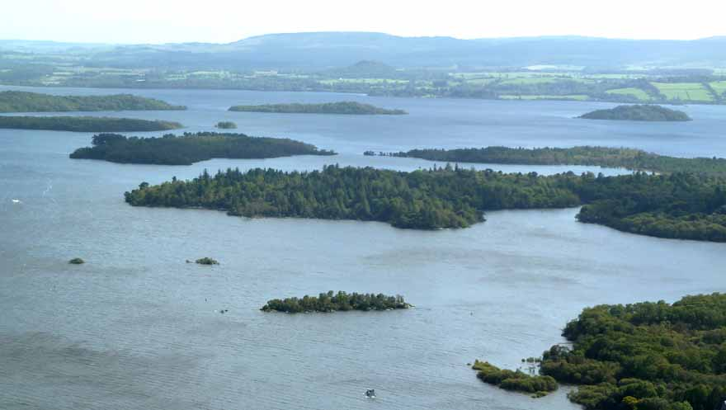
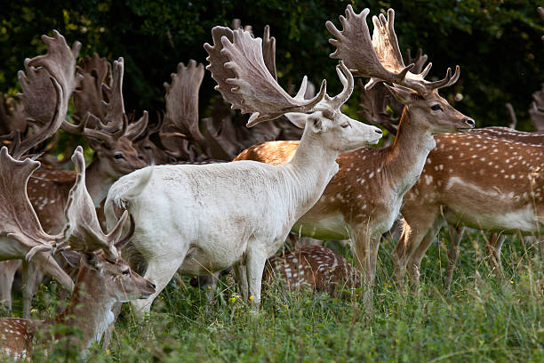

May 2025 updates in red
June 2026 updates in blue

Scottish Biodiversity Strategy
In preparing this new DMP 2024-2029, it is only prudent that we bring to the forefront the twin crisis of Climate Change and Biodiversity Loss, and the role that deer management has in addressing this emergency.
Scotland faces an unprecedented nature-climate crisis. In light of mounting evidence that Scotland continues to experience dramatic declines in biodiversity, the Scottish Government has set out an ambitious new framework to halt biodiversity loss by 2030 and reverse it with large-scale restoration by 2045. The ‘Scottish Biodiversity Strategy’ sets out the transformational changes needed to protect and restore terrestrial, freshwater and marine biodiversity in Scotland. The Strategic Framework includes a 5-yar delivery Plan https://www.gov.scot/publications/tackling-nature-emergency-consultation-scotlands-strategic-framework-biodiversity/pages/4/#:~:text=Set%20deer%20cull%20to%20level,per%20km2%20nationally%20by%202030.
The future of deer management will see significant changes to the status quo. The Scottish Government aims to (amongst multiple other objectives):
- Substantially reduce deer densities across our landscapes in parallel with ensuring sustainable management of grazing by sheep to improve overall ecosystem health. Reducing herbivore impacts is one of the biggest levers we have in Scotland for reducing biodiversity loss and enabling regeneration at scale. It is a pre-requisite for many of our nature restoration activities including peatland and woodland restoration.

- Introduce new deer legislation which will modernise the Deer (Scotland) Act 1996 and introduce new powers for intervention for the purposes of enhancing or restoring nature, including preventing biodiversity loss, by 2025.

- Set deer culls to levels at which habitats and ecosystems can recover, and regenerate and deer densities are maintained at sustainable levels and appropriate to context by 2030;

- We will work with the deer management sector to secure average densities of 2 deer per km2 in priority woodland, 5-8 deer per km² in the National Parks, and more widely a maximum of 10 deer per km² nationally by 2030.

- An additional 25% of the current National cull (50,000 deer) is required for the next decade. Then a maintenance cull will be required for several years. This will come from the lowlands.

The scale and pace of deer management in Scotland is going to substantially increase, and it’s happening now.

Introduction
The Loch Lomond Islands hold one of the few fallow deer populations in Scotland. Deer are free to swim from island to island and to the mainland, with fallow populations also present on the East mainland near Balmaha and the West mainland near Luss. It is assumed immigration and emigration occurs within the fallow deer population naturally at specific times of year and/or due to disturbance.

Deer at appropriate densities can be a valuable tool to the management of native woodlands; but where densities are too high this can result in negative impacts. There are several designated sites on the Loch Lomond Islands which are notified for the woodland features, which herbivores, in particular deer, are having a negative impact on.

Deer Management is essential to assist the sustainable management of the islands, and to protect these special features. Deer control has taken place across the islands for many years, however in 2010, a Collaborative Deer Management Group was formed; this allowed a platform for open engagement for discussing deer management, setting and reporting culls, and any other concerns of islands land managers.

The Purpose of the DMG

The overall aim of the D.M.G is to achieve natural regeneration of the woodland in the presence of deer; this is achieved by collaboratively managing the deer population (in particular the fallow) on the Loch Lomond Islands, whilst taking the highest regard for deer welfare.

Objectives

- Manage herbivore impacts on natural woodland regeneration and ground flora, by managing the deer densities to limit negative impacts.

- Achieve favourable condition of the designated features.

- Develop a collaborative approach to deer management throughout all the islands.

- To promote deer and deer management to the wider public audience.

Plan Implementation

The D.M.G require information gathered from habitat monitoring, population census and cull reporting to agree and set culls on an annual basis. Each management unit (i.e. island) is committed to implementing the necessary culls to achieve this; though it is accepted that there may be specific geographical areas within the D.M.G where deer management requires more focus. Collaboration is at the heart of the D.M.G; together we will deliver the objectives of the plan through our annual meetings and ad-hoc correspondence to discuss deer management issues that arise in the local and wider area.

D.M.G Location

The D.M.G lies in central Scotland, and spans three Local Authorities, Stirling, West Dunbartonshire, and Argyll & Bute Regional boundaries. The islands are situated in the southern end of Loch Lomond.

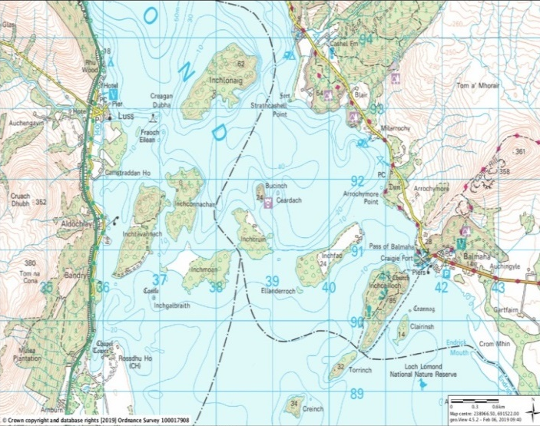
Maps: Location of the DMG within Scotland; a close up of island positions on the Loch.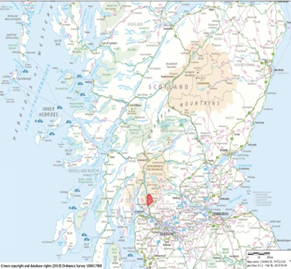

Management Units (The Islands)

There are 12 significant islands combining to a total of 488 ha. Within the D.M.G there are several key memberships (see Appendix 1 –Summary of the landownership). The islands are varied in size from Buccinch at 3.1 ha to Inchmurrin at 114.7 ha. All the islands have woodland cover, with predominantly native deciduous trees, and some islands with native conifers too. The topography of each island also varies from island to island, with some flat low-lying islands, such as Clairinch and Inchcruin, to the more rugged landscape of Inchcailloch and Inchconnachan. The islands are full of history and character, where each island has its own story.

Designations

Designations that the islands contribute to include: (please refer to Appendix 2 for more detail).
- Loch Lomond SAC
- Sites of Special Scientific Interest
- Loch Lomond National Nature Reserve
- Loch Lomond Special Protection Area
- Loch Lomond National Scenic Area

The main designated features are:
- Upland oak woodland
- Western acidic oak woodland
- Wet Woodland
- Raised Bog

Each designated site has its own Conservation Objectives (see Appendix 3). In general, this involves promoting natural regeneration to take place, whilst achieving a healthy ground flora layer to the benefit of wildlife.

Data Gathering

Habitat Monitoring - Method

Initially in 2008 - 2013 the method of habitat monitoring was via the Woodland Profile Survey (WPS). In 2015 WPS was superseded with the Armstrong method “Assessing Herbivore Impacts in Woodlands: A subjective Method” a.k.a. Woodland Herbivore Impact Assessment (WHIA). This is a method of assessing and monitoring the impact of large herbivores (cattle, sheep, deer, goats, pigs, horses) on habitats that are already wooded or may develop woodland. The method is subjective in that it is based on observations, not detailed measurements. Instead, it depends on the observer paying close attention to the overall appearance of the habitat as well as to particular indicators within the habitat. The method is suitable for land managers wishing to monitor herbivore impacts on a regular basis with the aim of adjusting herbivore pressure, either by deer culling, or by adjusting the stock grazing regime, to achieve a particular woodland condition target. The WHIA document is too large to be included in the annex of this DMP, but you can request a copy by following this link WHIA 2020. WPS and WHIA are different methods, and their results cannot be directly compared. To avoid confusion, this DMP will report on habitat data collected by WHIA since 2015.

Habitat Monitoring - Results

Table: HIA results from 2015-2026

Interpretation of HIA results

The results of an HIA are recorded on a scale from ‘No impact’ to ‘very high impact’. No Impact and Low impacts will eventually allow a woodland to regenerate with the greatest biodiversity. Any impact of Low/Medium and above will not allow the desired regeneration.

Conclusion of HIA Results

- Overall, the islands are failing their HIA’s.
- Deer pressure is ultimately too high and needs reduced.

Deer Census

Foot Counts

Whilst the HIA is the primary means of assessing herbivore impacts, it is also valuable to have an estimate of the current deer populations across the islands. Deer Counts can provide a snapshot of the population for that moment in time. Counting deer is challenging at the best of times, deer can evade humans quite easily (even on an island), and fallow deer in particular are skilled at sitting low down in vegetation and going undetected. Foot counts were conducted in 2008, 2012, and 2018. These counts were conducted through the collaboration of NatureScot, FLS, LLTNP, and several volunteers. There was full co-operation from island landowners/managers, and this contributed to the success of the count operation (See Appendix 4).

Table: Deer Count Density from Foot Counts in 2008, 2012, and 2018.
*This figure is Pre-Cull of Does, thus, not directly comparable to the other two count densities.

Drone Counts

In 2022, for the first time, we conducted a deer count by using a drone. The drone enabled us to take photos and videos. Using the drone’s thermal camera, we were able to locate the body heat signatures of the deer, leaving them nowhere to hide. Thanks to this technology we can now get an accurate deer count in a fraction of the time (see appendix 5). We were surprised to count a total of 137 fallow deer. These results raised more questions than answers. Where the previous foot counts incredibly under-counting the deer? Is there a substantially greater influx of deer to the islands than we had estimated? In April 2024 the count was repeated, and we counted 130 deer. In April 2025 the weather was unusually warm/bright, and we had to reschedule the drone count twice. When we eventually counted the islands, the weather again wasn’t ideal, and the drone and pilot struggled to pick-out herbivores. The count was most likely an under-count of the herbivore population. There were aspirations to conduct another count in November 2025 to better understand the true population. Inchcruin was not counted due to the presence of an osprey on nest. In November 2025 the repeat count was conducted and counted 118 fallow.

Table: Results of all drone deer counts.
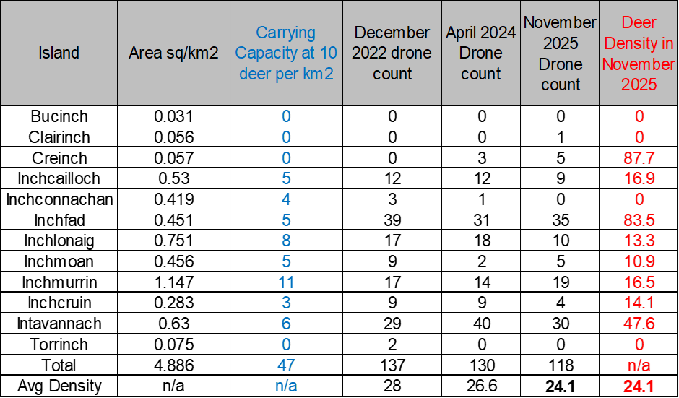

Drone Deer Count – Mainland

There has always been an unknown population of fallow deer on the Loch Lomond NNR. It no secret that these deer swim across to the islands (the number of deer that make this journey remains unknown). NatureScot commissioned a drone deer count in November 2022 to get a snapshot of this fallow population. We counted 46 deer (16 red, and 30 fallow). The total land surveyed was ~1.46km², this is 1 km² wood, surrounded by 0.46km² field (give or take). In April 2024 we repeated the count and recorded 52 deer (22 Red, 1 Roe, 29 Fallow). Throughout the winter of 2024 NatureScot conducted several in-house drone counts, the conclusion is there are 30-40 fallow, and a small red herd hefted to Gartfairn Woods. In the winter of 2025, the drone counted 54 fallow and 44 red. These deer need reduced in line with the targets set in the Scottish Biodiversity Strategy. NatureScot have spoken to the landowner, and he has agreed to reduce this population. These two populations are interconnected, and as with the island population, NatureScot intends to conduct annual drone counts to ensure that this population is reducing.

Other Herbivores

It is recognised that managing deer is only part of the solution to managing herbivore impacts. Deer damage needs to be differentiated from other herbivores – livestock, goats, wallabies. Further management of grazing animals will be required to assist in delivering the desired objectives.

Livestock
Changes in livestock management can help deliver the required land management objectives – both agricultural and conservation. Inchtavannach is the only island that has had livestock either historically or at present. Past management has included sheep, but these have all been removed and there is no plan to re-introduce them. The tenant of this island does still have cattle and horses on the island all year round. NatureScot intend to work with both the landowner and the tenant farmer to discuss their management aspirations for the island and what measures can be implemented to improve the condition of the woodland.

Wallabies
Wallabies are a non-native species and as such careful consideration needs to be given to managing their population. Wallabies are found only on Inchconnachan (although they can swim). They are both grazers and browsers and therefore can cause serious impacts to the flora of Inchconnachan. Since 2008, the wallaby population has reportedly been reduced. The drone count in December 2023 counted between 10-12 wallabies. 12 on an initial fly over, and then 10 on a second pass. These missing 2 wallabies were likely hidden in a crevice. In April 2024 we counted a total of 8 wallabies during our annual drone count. In April 2025 the drone only pick-out two animals, but the November 2025 count found 9 wallabies.

Geese
Canada geese are resident on the islands, and it has been suggested that the population has been steadily increasing over the years. The geese are most obvious on Torrinch and Inchlonaig, where these islands seem to be preferred breeding locations. The geese are herbivores and do eat the vegetation, but the failing HIA’s have not placed the blame on the geese. At present there is no geese control occurring on any of the islands. In the future, if the DMG feel that geese control is required, then Canada geese are covered by the General Licence.

Other Factors Preventing Regeneration

It is also recognised that herbivores are not the sole factor in preventing sufficient regeneration from occurring. Practical management must also take place on the islands to limit or prevent other factors from inhibiting regeneration.

Canopy Cover
Native woodland canopy cover will dieback naturally allowing open spaces to be created; this is a natural process and will continue to occur in due course.

Bracken
Bracken management should be pursued to create open areas and prevent competition.

- Inchlonaig suffers from bracken encroachment, and whilst control has taken place previously, no follow up treatment nor active management has occurred recently; the extent of the bracken is as bad as ever. Stalker has made comment that the bracken is inhibiting deer control and that we need to manage the bracken. In 2026 the bracken has still been highlighted as an issue.

Non-Native Plant Species: Beech
Non-native plant species should be removed where possible, either by felling of trees, or through pulling up seedlings and saplings.

- In 2015, Inchtavannach was subject to INNS Beech tree management, where roughly 145 Beech trees were ring-barked/injected with Glyphosate; the majority of these trees were in the Southwest of the island. In 2019 further management is planned to remove these ‘dead’ trees.

Non-Native Plant Species: Rhododendron
Rhododendron removal will be key to ensuring suitable ground conditions for favourable condition.

- Inchmoan and Inchconnachan have a significant issue with Rhody’s but no active management is being carried out.

- Inchmurrin is in the process of removing rhododendron from the designated site area; further work is carried out on Luss estates islands to remove rhododendron and their seed source.

- Inchtavannach has previously had Rhody control and this was pretty successful and almost eradicated the problem. There has been no active management since 2014 and so the rhody re-growth has returned.

Deer Density estimates related to Targets.

This DMG has been going for the last 14 years. Initial densities were estimated around 50 deer per km2 (and likely higher). The initial density target set by the DMG was to reach 15 der per km², and then to assess the condition of the habitat. After 14 years this target was never achieved. The Scottish Government (via the Scottish Biodiversity Strategy) in 2023 suggest targets of 2 deer per km2 in priority woodland, and 5-8 deer per km2 in the lowlands; and 10 on the open hill. Whilst priority woodlands have yet to be defined (as of 8/5/2 as this DMP is updated), it’s a safe bet to assume that SSSI woodlands may be regarded as priority woodlands. Whilst we await clarification of the currently suggested lowland deer density targets, we should at least be aiming for 10 deer per/km². The National Park Authority have expressed a desire to reach 5 deer per/km².
Regardless of the estimated deer population, the appropriate deer density will be informed through HIA to assess deer impacts on preventing regeneration. This method of habitat monitoring is more accurate and informative than simply aiming for a density target. Nevertheless, by reaching this lower population level it will be easier to manipulate the population from certain islands to promote regeneration, whilst ensuring the fallow presence on the other islands.

To achieve our objectives, it is extremely important that the DMG has ongoing drone counts and WHIA resource in place for future years.

Seasons and Authorisations

On the 27th September 2023 changes to the Deer (close season) (Scotland) Order removed the close season for all species of male deer in Scotland; effective from 21st October 2023. It is now legal to shoot male deer all year round. Fallow female seasons remain unchanged for now (21st October – 15th February) but will be reviewed as part of the new Natural Environment Bill (replacing the Deer Act Scotland) in 2025. Longer open seasons will give us increased time to cull more deer.

Out of Season and Night shooting Authorisations can also be potential tools to ensure the population is managed sustainably to prevent damage to woodland. The use of Out of Season Authorisations have been used since 2017 across the some of the islands.

Carcass Disposal

Deer carcasses and grallochs should be removed from the islands where possible. This will assist in safeguarding public perception and ensure deer control is carried out discretely in high public access areas. Individual landowners/managers should make suitable arrangements per their island(s) regarding deer control/ extraction/ sale of carcasses etc. A collaborative approach for control/ extraction/ sale may be possible and should be encouraged.

Cull Action Plan

- To meet designated site conditions and prevent damage from occurring, landowners/ managers should appoint competent and knowledgeable individual(s) to carry out deer control on their behalf. NatureScot can advise on suitable individuals who would be able to carry out this control if required. All control will/should follow the appropriate legislation and Wild Deer Best Practice Guidance.

Culls – historical

The deer counts and HIA surveys have evidenced that the deer population remains too high to allow for sufficient natural regeneration of the woodlands. A substantial reduction of deer numbers is required to achieve favourable conditions of the designated sites. Once the deer population has been reduced to a level that allows regeneration to occur, the cull will become dynamic to meet the management objectives, most likely reverting to a cull of the recruitment level. The table below displays the cull data from 2010-2026. Cull data will be recorded and shared annually with the other relevant landowners, to provide a sound base on advising on future deer management. Recorded data should include date and location, species killed, sex, estimated age class, body weight, and female reproductive status. Cull data will continue to be reviewed bi-annually, particularly in the early stages of addressing the reduction cull.

Table: Cull Summary 2010 – 2026: This table shows the Total combined cull figures for the entire DMG. Please note, I have made a change to the recording of culls. The East Mainland culls were previously added to the islands; however, this was wrong! The east mainland was already being recorded under the East Loch Lomond Land Management Forum. Therefore, I am no longer including their culls in this DMG. We will still reference to them as they are relevant to this DMG.

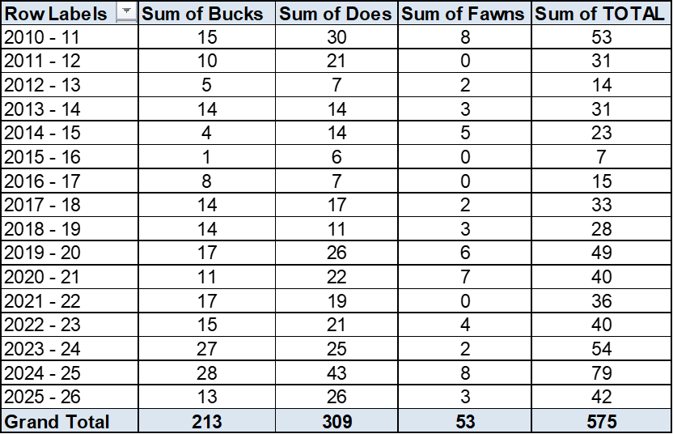

Culls – future targets

Culls have historically been 30-50 fallow; in 2024/25 and 25/26 we set higher cull target to address the drone count results. It was felt a cull of around 50 deer is just maintaining this population at its current level. Cull targets will be set with the intention of reaching the population target as quickly as possible.

Population models can be used to give a rough steer of deer populations and cull targets to achieve the desired population density. Within this DMG the models have never been close to the reality on the islands. In April 2026 it was decided to omit future models with the justification that they were using resource but returned little benefit. The model below has been left in this DMP purely to illustrate the type of model that we have historically used.

Using the population model with the April 2025 drone count as a starting point we can estimate the time frame it should take reach the target density (~10 deer per/km²). Our short-term target is to reach a density of 10 deer per km². These models are not 100% accurate. Rather, use this model as a ‘guide’ to illustrate the direction that we want the population to move towards. If we conduct a drone count in November 2025 we can use the results to update this population model as well as the cull targets. As explained above, we dropped the use of the population model.

Assumptions:
Net Loss is mortality, poaching and migration

• Spring fawn pop’n is split 50:50 between summer bucks and does.

Net Loss = 5% bucks, 5%does & 10% fawns (based on taking account of possible illegal control and out with migration from a building population)

Calving = 63%
Target = Target population – to reach a density of 10 deer km2, (50 deer) in the summer.

Public Access

- The islands and surrounding landscape are open to public access. Both mainland shores are heavily used, especially along the route of the West Highland Way. The islands are also used, although access is restricted. There is a risk that viewing of firearms, carcasses etc. can cause potential for conflict with members of the public regarding deer control. An openness and non-conflict approach by individuals carrying out control will be required to help promote the understanding of deer management across the area.

- All deer controllers must be aware of the public access to all areas, including water users and ensure a safe backstop before any shot is taken and deer control is carried out to Best Practice.

- Visitor numbers to the islands are steady from March till December (visitors can still be found outside these months). On some islands there have been reports of semi-permanent campsites. This is a challenge for the stalkers who must be aware that people maybe present all year round on the islands. The National Park is aware of these campsites, but the situation is complicated (legally), and it’s not very easy to move these people off the islands.

Fencing

- Following Joint agency fencing guidance due to the size and nature of the islands, and public access, fencing is not a realistic/viable option to aid regeneration.

Sustainable Deer Management and the Public Interest

The management of deer at a landscape population level as set out in the Code of Practice on Deer Management (The Deer Code) https://www.nature.scot/professional-advice/land-and-sea-management/managing-wildlife/managing-deer/code-practice-deer-management requires a collaborative approach. Deer are regarded as a natural resource and as such all those who manage them have a ‘responsibility’ to:
- Manage deer as a resource sustainably.
- Minimise negative deer impacts on public interest.
- Safeguard deer welfare.

The members of the DMG are aware of their responsibilities as set out above.

Annual Evaluation and review

Are we meeting our Group Objectives?

- Manage herbivore impacts on natural woodland regeneration and ground flora, by managing the deer densities to limit negative impacts.

- We have demonstrated that we are managing deer densities. The evidence for this is the reducing deer population from ~242 deer (2008) to 118 in November 2025. Deer numbers remain too high, and we will continue to reduce these fallow populations.

- Achieve favourable condition of the designated features.

Currently we have not achieved this objective; only two islands are currently in favourable condition. It’s worth bearing in mind that these islands have not been monitored via SCM for several years; it is likely their statuses will change with the results of the next suit of SCM.

The main designated features are:

- Inchconnachan – Upland Oak Woodland – Unfavourable Declining
- Inchtavannach – Upland Oak Woodland – Unfavourable Declining
- Inchmoan – Raised Bog – Unfavourable No Change
- Inchlonaig – Upland Oak Woodland – Unfavourable No Change
- NNR islands:
- Inchcailloch – Upland Oak Woodland – Favourable Maintained
- Torrinch – Upland Oak Woodland – Unfavourable Declining
- Creinch – Upland Oak Woodland – Unfavourable Recovering
- Clairinch – Upland Oak Woodland – Unfavourable Declining
- Inchmurrin – Wet Woodland – Favourable Recovered

- Develop a collaborative approach to deer management throughout all the islands.

- We have developed a good collaborative approach. Although we only meet annually, we do keep in touch via email and phone. NatureScot and LLNTP have a good collaborative working relationship and are all involved within the DMG.

- To promote deer and deer management to the wider public audience.

- We probably could be more pro-active here, and this is something that the members may wish to discuss in future AGM’s. As the National Park is a Scottish Government priority deer site, there has been more engagement with the public, and more publicity of this DMG within the deer sector.

- In 2024 this D.M.P went online via the National Park website. This will promote the DMG to the wider public.

Overall Conclusion

The overall aim of the DMG is to “achieve natural regeneration of the woodland in the presence of deer”. To achieve this, we need to reduce deer impacts to a low enough level where regeneration can at least start. Progress over the last 14 years has been slow. In the face of the twin crisis of Climate Change and Biodiversity Loss, deer management is now under strict review. With a step change in deer control imminent, we should see a much faster reduction of deer density, ultimately resulting in improved regeneration of woodland.

Next Review of DMP

- Progress on the Deer Management Plan should be reviewed annually in the autumn, with full co-operation from all landowners/ managers.

- There will be a review of the success of the Deer Management Plan in 2029 in delivering the management objectives outlined above. At this point an agreement on future deer management should be sought.

Appendix 1 – Summary of island landownership

Table: Summary of the islands of the L.L.I.D.M.G.

Appendix 2 – The 5 Types of Designations in the DMG

Within the DMG area there are five different types of Designations, and each designated site has its own Conservation Objectives. In general, this involves promoting natural regeneration to take place, whilst achieving a healthy ground flora layer to the benefit of wildlife.

National Nature Reserve (NNR) = Inchcailloch

The first National Nature Reserves were designated 50 years ago, and at that time they were the cornerstone of nature conservation policy, safeguarding sites of national conservation importance as well as providing interpretative material and allowing the public to enjoy these sites. These days aalthough NNRs must be well managed for wildlife, people are also encouraged to enjoy these special places too. Visitor facilities are designed and managed to ensure that people can enjoy the reserves without harming or disturbing the wildlife that lives there. There are currently 41 National Nature Reserves in Scotland.

Sites of Special Scientific Interest (SSSI) = Inchconnachan; Inchtavannach; Inchmoan; Inchmurrin; Inchcruin; Inchlonaig; Inchcailloch; Torrinch, Clairinch; Creinch.

Sites of Special Scientific Interest (SSSI) represent the best of Scotland’s natural heritage. They are ‘special’ for their plants, animals or habitats, their rocks or landforms, or a combination of such natural features. Together, they form a network of the best examples of natural features throughout Scotland, and support a wider network across Great Britain and the European Union. Scottish Natural Heritage chooses sites after detailed survey and evaluation against published scientific criteria.

Special Protection Area (SPA) = Inchconnachan; Inchtavannach; Inchmoan; Inchcruin.

A Special Protection Area (SPA) is an area of land, water or sea which has been identified as being of international importance for the breeding, feeding, wintering or the migration of rare and vulnerable species of birds found within the European Union. Together with SACs, Special Protection Areas are designated under the European Wild Birds Directive which forms the NATURA 2000 network of sites. A number of SPAs include areas notified as SSSIs and the additional SPA designation affords these areas enhanced protection.

National Scenic Area (NSA) = Every Island in the DMG lies within this designation.

National scenic area (NSA) is a conservation designation used in Scotland, and administered by Scottish Natural Heritage (SNH). The designation’s purpose is to identify areas of exceptional scenery and to protect them from inappropriate development. Scotland is renowned for its outstanding scenery, and 40 of its very best areas have been designated as National Scenic Areas (NSAs). Legislation defines these as areas “of outstanding scenic value in a national context”.

Special Area of Conservation (SAC) = Loch Lomond SAC (Inchconnachan; Inchtavannach; Inchlonaig; Inchcailloch; Torrinch, Clairinch; Creinch).
Special Areas of Conservation (SACs) are areas designated under the European Directive commonly known as the ‘Habitats Directive’. Together with Special Protection Areas, which are designated under the Wild Birds Directive for wild birds and their habitats, SACs form the Natura 2000 network of sites. Most SACs on land or freshwater in Scotland are also underpinned by notification as Sites of Special Scientific Interest (SSSIs). The additional SAC designation is recognition that some or all of the wildlife and habitats are particularly valued in a European context.

Appendix 3 – Designated Sites and their Conservation Objectives

Table: Designated Sites Summary. The data included in this table was collated from the NatureScot Site Condition Monitoring webpage, and from Site Link website (https://sitelink.nature.scot/home).

Appendix 4 – Maps of Deer Counts on Foot

2008 count
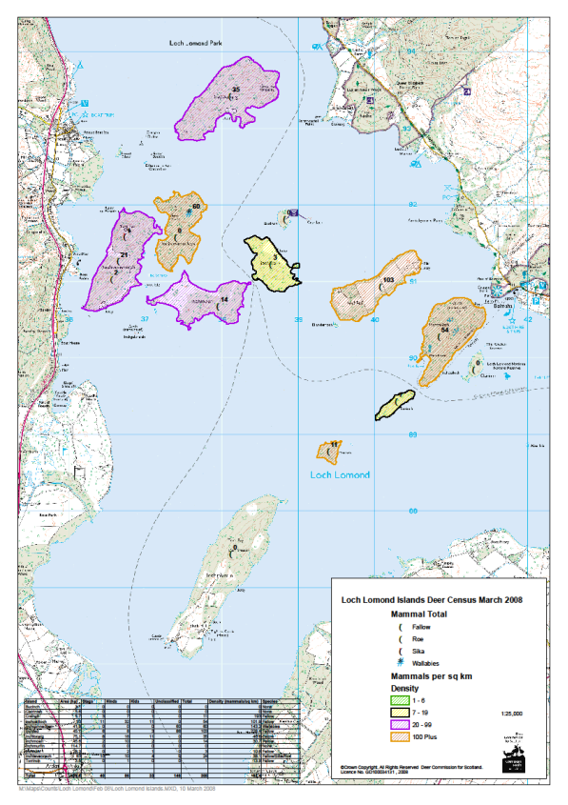

2012 Count

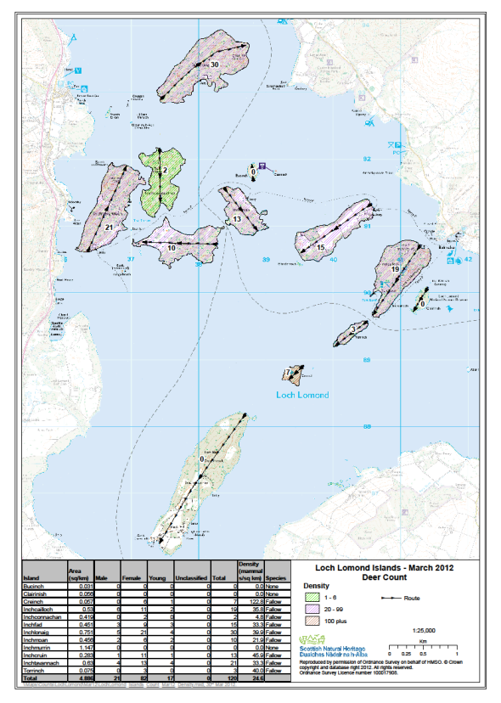

2018 Count

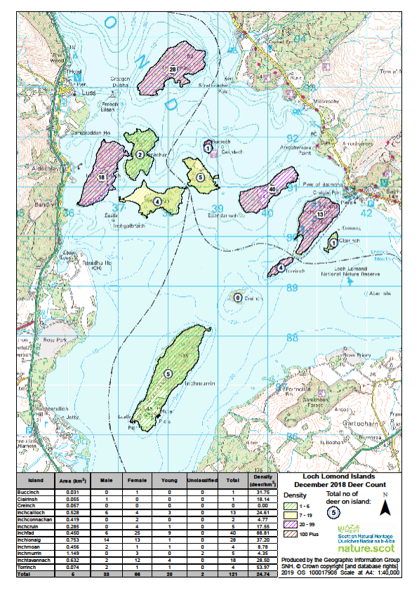

Appendix 5 – Maps of Deer Counts by Drone
December 2022

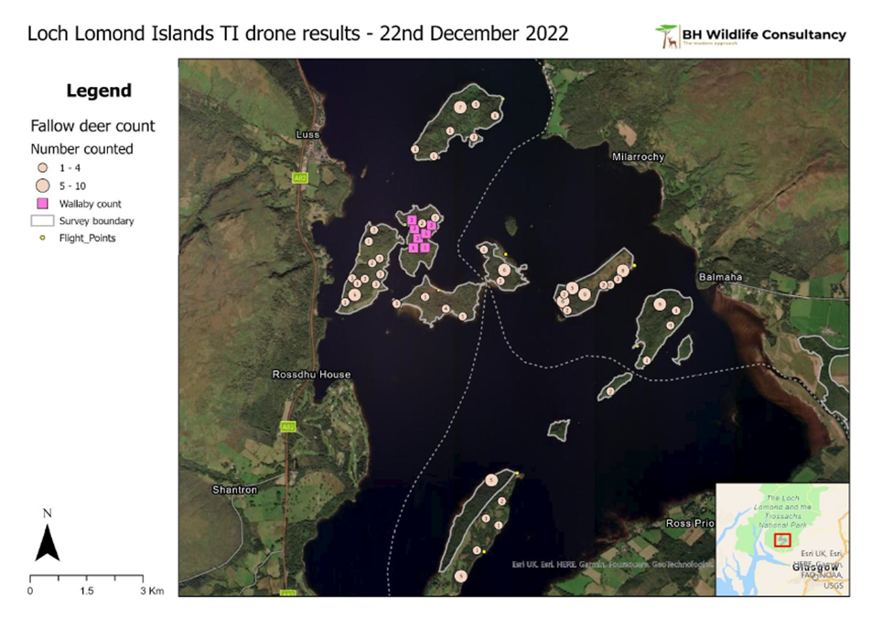

April 2024
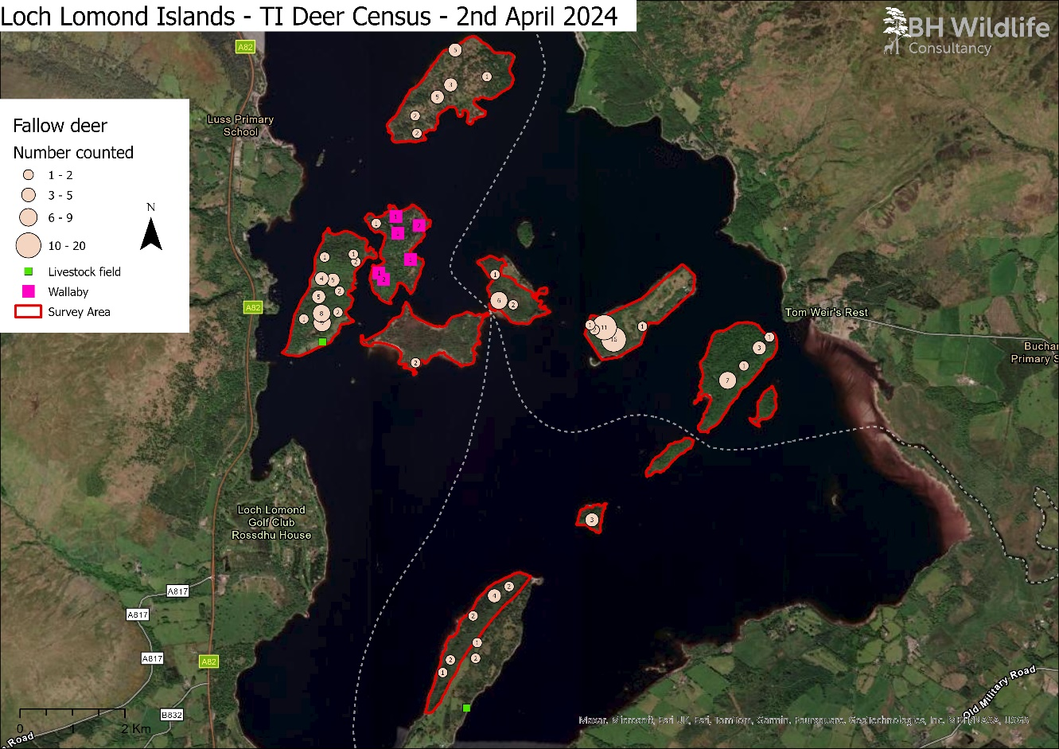
April 2025

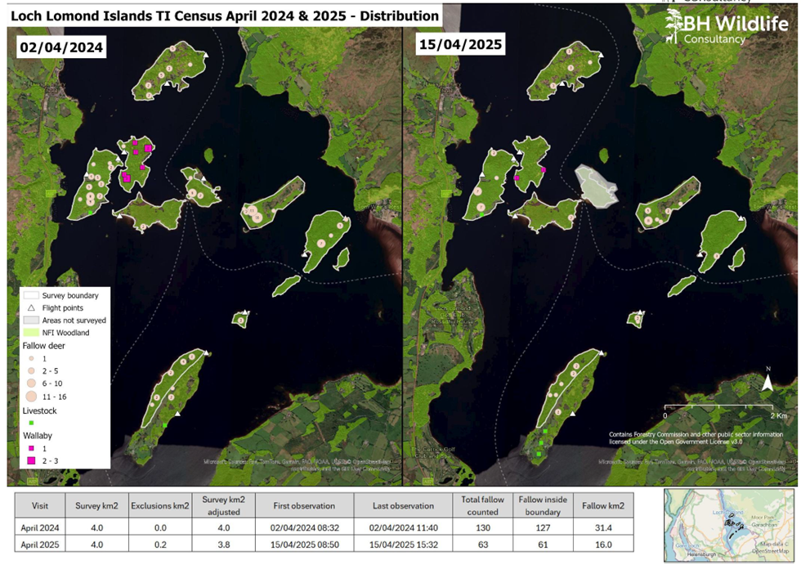

November 2025

