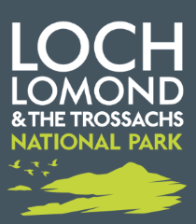
Consultation about

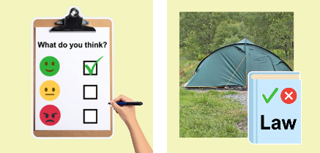
camping byelaws
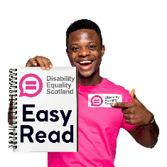
Easy Read

About this document
 | This is an Easy Read document.
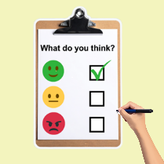 | It is a consultation.  A consultation is a set of questions to find out what you think about something.
 | This document will:  - tell you about Loch Lomond and The Trossachs National Park  - tell you about changes we might make to some byelaws about camping in the National Park  - ask you 4 questions  - tell you how to give us your answers
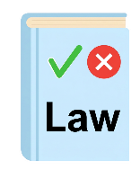 | Byelaws are special laws to say what people can and cannot do.

About Loch Lomond and The Trossachs National Park
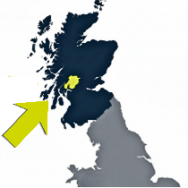 | Loch Lomond and The Trossachs National Park is a huge outdoor area in the west of Scotland.
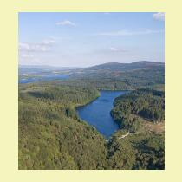 | The National Park has:  - 40 mountains  - 22 big lochs or lakes  - 50 rivers  - 2 Forest Parks
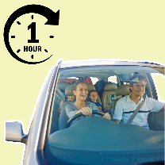 | More than 15 thousand people live in the National Park.  Half of everyone in Scotland lives 1 hour’s drive or less from the National Park.
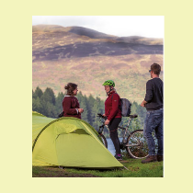 | People come to the National Park to:  - walk  - cycle  - hike  - camp  - birdwatch  - swim  - be in nature
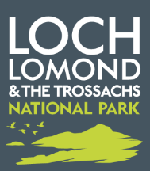 | Loch Lomond and The Trossachs National Park Authority help look after the National Park.

About this consultation
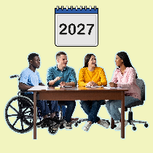 | Every 10 years we look to see if any of our camping byelaws need changing.
 | This consultation asks you what you think about the camping byelaws we think need to be changed.
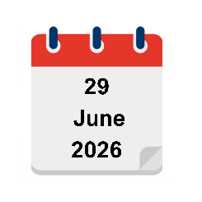 | The consultation begins on Monday 29 June 2026.
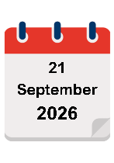   | It ends on Monday 21 September 2026.
 | After that we will look at everyone’s answers.  The answers will help us write to the Scottish Government Ministers with the changes we want to happen.

About the camping byelaws
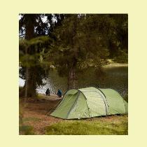 | Lots of people enjoy coming to Loch Lomond and The Trossachs National Park to camp.
 | But there were problems with:  - too many people camping  - bad behaviour of some people camping  - how these 2 things affect other people and the environment
 | In this document the environment means everything around us, like the ground, the water and the air.
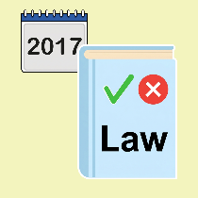 | Since 2017 camping byelaws have been in place every summer.
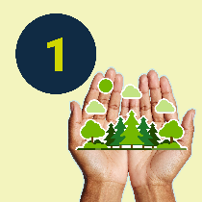 | The camping byelaws have 3 aims.  1. To look after the environment.
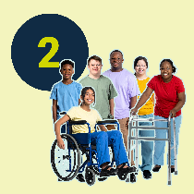 | 2. To make sure that there are lots of different chances for people from all kinds of different backgrounds to camp at accessible places in the National Park.
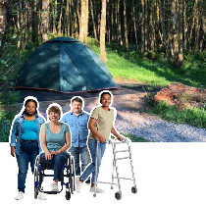 | In this document accessible places means camping spaces that are easier get to.
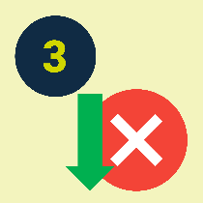 | 3. To have fewer problems like:  - unsafe fires and leaving burn marks  - breaking tree branches  - being too loud  - places getting too crowded  - leaving rubbish behind  - being aggressive to staff

Camping in the National Park
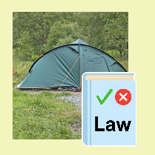 | The National Park is a beautiful and special place.  The camping byelaws have made a big difference since 2017.
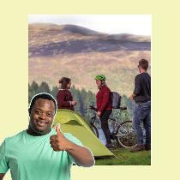 | More people are camping.  Fewer people are complaining of problems.  There is less damage to the National Park.
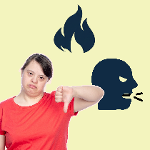 | But some things have got worse.  There are more fires.  More people are being aggressive to staff.
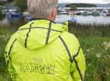 | Staff who work around the National Park are called Rangers.

Byelaws we are thinking about changing
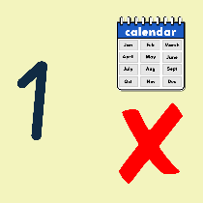 | We have talked about 5 changes.  1. Which months of the year the camping byelaws happen.  We do not want to change these.
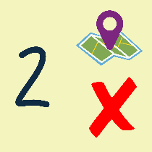 | 2. The areas of land that the camping byelaws cover.  We do not want to change these.
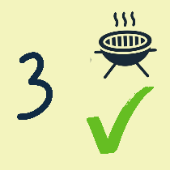 | 3. Using fires and barbecues.  We want the new camping byelaws to say:  Fires must be inside a container like a fire pit or a fire bowl, off the ground.  If a Ranger asks you to put your fire out you must do it.
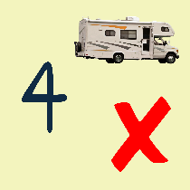 | 4. Rules about motorhomes and campervans.  We do not want to change these.
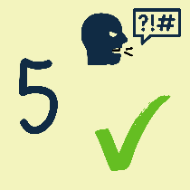 | 5. The safety of our Rangers.  We want the new byelaws to say:  It is a criminal offence to be aggressive or abusive to a National Park Officer.
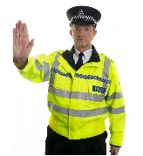 | In this document a criminal offence means someone breaking the law.
 | In this document aggressive or abusive means things like:  - shouting or swearing at them  - threatening or hurting them  - treating them unfairly

Some smaller changes
 | There are some smaller changes we would like to make too.
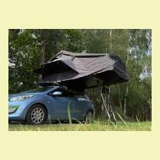 | For example we want to include roof top tents on vehicles in our camping byelaws.
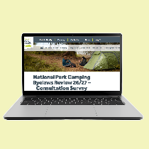 | If you want to find out more about these smaller changes, you can click on our website: lochlomond-trossachs.org/haveyoursay  It is not in Easy Read.

Our questions for you
 | We want to know what you think about these changes to the camping byelaws for Loch Lomond and The Trossachs National Park.  You can answer these questions in 3 ways.
 | 1. You can print out the questions and write your answers.  Use the Enter button to grow the answer spaces before you print.
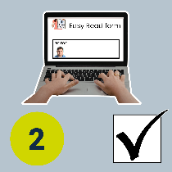 | 2. You can type into the answer spaces in this document.  The spaces will grow as you type.  To tick a box you can tap and a tick will appear.  If you change your mind, tap again and the tick will go.
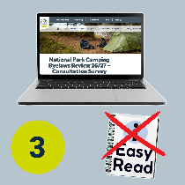 | 3. You can answer online on our webpage: lochlomond-trossachs.org/haveyoursay  It is not in Easy Read and the question numbers will look different.
 | You do not have to answer all the questions if you do not want to.
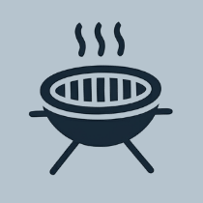 | Question 1  Do you agree with changing the camping byelaw about fires and barbecues?  Tick 1 box.
 | Yes, I agree. | ☐
 | No, I do not agree. | ☐
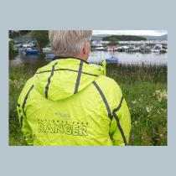 | Question 2  Do you agree with changing the camping byelaw about keeping our staff safe?  Tick 1 box.
 | Yes, I agree. | ☐
 | No, I do not agree. | ☐

 | Question 3  Thinking of the other 3 parts that we do not want to change, is there anything you want to say about these?
Tell us here.

 | Question 4  Do you have any other camping byelaw changes to suggest or anything else to tell us?
Tell us here.

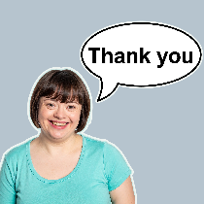 | Thank you for your answers.

What to do next
 | You can send us your answers these ways.  1. You can email them to us at cmbreview@lochlomond-trossachs.org
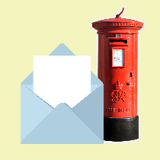 | 2. You can send them to us at  National Park Authority  Carrochan Road  G83 8EG
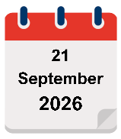 | Please send them before  Monday 21 September 2026.


Disability Equality Scotland used pictures from BaseSix and Canva to make this Easy Read document.

